Ph.D. Thesis

Development and Evaluation of Mixed Reality Educational Applications

June, 2018

Graduate School of PaiChai University

Department of Game Multimedia Engineering

Xiaoyun Duan

Development and Evaluation of Mixed Reality Educational Applications

Supervisor: Soo Kyun Kim

June, 2018

Graduate School of PaiChai University

Department of Game Multimedia Engineering

Xiaoyun Duan

The undersigned have examined the dissertation entitle: "Development and Evaluation of Mixed Reality Educational Applications" presented by Xiaoyun Duan, a candidate for the degree of Ph.D. in Game Multimedia Engineering and hereby certify that in their judgment it is worthy of acceptance.

Advisor

June, 2018

__________________

Soo Kyun Kim Ph.D.

Professor

Dept. of Game Multimedia Engineering

Graduate School of PaiChai University

Principle Examiner

June, 2018

__________________

Sung Ohk Ahn Ph.D.

Professor

Dept. of Game Multimedia Engineering

Graduate School of PaiChai University

Examiner

June, 2018

__________________

Ph.D.

Professor

Examiner

June, 2018

__________________

Examiner

June, 2018

__________________

Development and Evaluation of Mixed Reality Educational Applications

XiaoYun Duan

*Department of Game Media Engineering*

*Graduate School of PaiChai University, Daejeon Korea*

(Supervised by Professor Soo Kyun Kim)

Ancient Chinese people advocate the education proposition that “it is better to travel ten thousand miles than to read ten thousand books”, which means that one who wants to attain achievements could never make it simply by reading. Reading harvests intelligence but travel harvests experiences. While such experiences could sublimate to intelligence more practical and more important than that learned from books. The intelligence of the ancients reminds people that knowledge and experience supplement each other in education. However, limited by the implementation conditions in reality, education oriented towards the public lays emphasis on reading but overlooks intuitional stimulus to sense organs and knowledge taught by experience and comprehension. Personal experience is of vital importance to education. However, under traditional education mode, due to the limitations in time and space, schools usually fail to provide enough experiential environment for students and it is extremely inconvenient to implement experiential teaching in practice. Whereas, along with the fast development of computer technology, high immersive game experience in the film Ready player one might come true in the near future. Computer simulated reality represented by virtual reality technology and augmented reality technology could replace the “travel for ten thousand miles” and fill in the blank in this field. For instance, teachers could introduce local topography in geography class, introduce the living environment of local plants and animals in biology class, introduce the augmented microworld in real world and allow students to timely conduct experiments in chemistry class. More importantly, free from the restriction in time and space, this technology could be repeated adopted. While initiating a revolution to traditional education, it also brings about infinite development potentials.

How to better apply virtual reality and augmented reality technology in teaching and how to make the advantages of intellectual technology and traditional teaching method complementary to each other has always been a problem to be explored by education researchers and front-line education practitioners. Students could transform from passive receivers to active learners in autonomous experience process. This will be propelled by virtual reality technology and augmented reality technology. MR exactly integrates the two technologies. Both of the two technologies emphasize simulated environment and users’ real experience and sense of participation. At present, virtual reality has been applied in many fields. This thesis elaborately introduces the core technology and application situation of virtual reality and augmented reality in education and designs and develops three AR and VR education application implementation cases, namely 1VR art exhibition, 2 AR 3d Coloring game and 3 MR Chemistry Lab. Subsequently, the thesis respectively sets forth the design and development process of every application. Eventually, in combination with the practical application use experience of experimental subjects, the thesis analyzes the education effects, user experience, equipment features, and implementation effects of these applications, expounds the advantages comparing with traditional teaching mode and the means to integrate virtual reality technology with education teaching, and talks about the basic principles of application design and interactive design. Some referential experience and methods in AR and VR education applications derived in the thesis provide useful references for the improvement and enhancement of the application of virtual reality technology and augmented reality technology in education teaching.

**Keywords:** Virtual & Augmented Reality; Educational Application; Experiential & Interactive Learning, Game-based Learning

# **Table of Contents**

Abstract i

Table of Contents ii

List of Figures iv

List of Table v

I. Introduction

1.1 Concepts

1.1.1 Virtual Reality 1

1.1.2 Augument Reality 1

1.1.3 Mixed Reality 1

1.2 Objectives and Scope 1

1.3 Contribution 1

1.4 Dissertation structure 1

II. Related Work 1

2.1 Educational Applications Typical types and Examples 1

2.2 Interaction Design 1

2.2.1 The development of human- centered Interaction Design 1

2.2.2 Interaction Design for VR and AR 1

2.2.3 User Interface Design for VR and AR 1

2.3 Summary 1

III. VR Art exhibition 1

3.1 Implementation Methods 1

3.2 Game Design 1

3.3 Project Implementation 1

3.4 Conclusion 1

IV. AR 3D Coloring Game 1

4.1 Game Design 1

4.2 Implementation 1

4.3 Conclusion 1

V. MR Chemistry Lab 1

5.1 Game Design 1

5.2 Implementation 1

5.3 Conclusion 1

VI. Evaluation 1

6.1 Evaluation system 1

6.2 Evaluations for the 3 cases 1

6.3 Evaluation Result 1

6.4 Summary 1

VII. Conclusions 1

7.1 Review of Objectives 1

References 1

Korean abstract 1

Acknowledgement 1

# **List of Figures**

[Figure 1-1] 1

[Figure 1-2] 1

[Figure 2-1] 1

[Figure 2-2] 1

[Figure 2-3] 1

[Figure 2-4] 1

[Figure 2-5] 1

[Figure 2-6] 1

[Figure 3-1] **1**

[Figure 3-2] 1

[Figure 3-3] 1

[Figure 3-4] 1

[Figure 3-5] 1

[Figure 4-1] 1

[Figure 4-2] 1

[Figure 4-3] 1

[Figure 4-4] 1

[Figure 4-5] Ti 1

[Figure 4-6] R 1

[Figure 4-7] A 1

[Figure 4-8] D k

# **List of Table**

[Table 1-1] H 1

[Table 2-2] F 1

[Table 3-3] R 1

[Table 2-1] H 1

[Table 2-2] F 1

[Table 3-3] R 1

[Table 1-1] H 1

[Table 2-2] F 1

[Table 3-3] R 1

Ⅰ Introduction

In recent years, education game has become one research hotspot which resorts to technology to promote teaching. By utilizing network technology or intelligent instrument as the interactive medium to assist learning, improve learning participation degree and continuum, education game boosts the diversity of learning methods and the interactivity of learning process [1]. The researcher is devoted to the study on the promotion role of education game in learning from the perspective of teaching principles, learning activity design and technology application. How to maintain learners’ learning interests and improve learners’ learning effects is one of the great challenges confronted by education game research. How to make the advantages of intellectual technology and traditional teaching method complementary to each other has always been a problem to be explored by education researchers and front-line education practitioners. Research purpose of the thesis is exactly to figure out how to better apply the latest virtual reality and augmented reality technology in teaching. This chapter presents a brief overview of the context under which the research was conducted. Background information regarding this study is provided in order to establish research objectives and scope. Then, the contributions are discussed. Finally, the structure of the dissertation is outlined.

1.1 Concepts

Virtual Reality (abbreviated for VR) and Augmented Reality (abbreviated for AR) technology had been already proposed as early as the 1960s. In the early stage, the two technologies were classified into the development stage of frontier science. While mixed reality (abbreviated for MR) technology was raised by Ronald Azuma based on the development of AR and VR. As the human-computer interface which realizes natural interaction among the virtual environments generated by human and computer, VR, AR and MR all have extensive application development prospects.

Prime application fields of VR and AR include: 1. Industrial manufacturing and maintenance field which displays multiple auxiliary information to users via head-mounted displayer, including virtual meter panel, equipment interior structure and equipment parts drawing. 2. Medical field which utilizes VR method to help doctors diagnose diseases, cure patients and train medical staff. 3. Television replay field which supplements auxiliary information to replay scenes by virtue of AR technology. 4. Entertainment and game field such as VR games, VR videos and films. 5. Education field which realizes immersive teaching via VR. 6. News field which realizes 3D words and pictures, and increases reading interactivity and interests via VR. 7. Tourism and exhibition field which builds up digital scenic spots and exhibition and allows users to visit beautiful scenery of the world at home. For instance, municipal construction could take VR technology to supplement planning effects to real scenes and directly see the planning effects. Next, the following sections will introduce VR and AR technology.

1.1.1 Virtual Reality

Virtual Reality Immerses a user in an imagined or replicated world (like video games, movies, or flight simulation) or simulates presence in the real world (like watching a sporting event live). The world of VR exists all the time. Comic books, games and fictions all belong to VR in traditional sense, but they are limited by the visual sense and auditory sense of mankind. Above all, they could not create immersive sense for users.

Nowadays, VR technology mainly refers to the three-dimensional VR based on head-mounted equipment. This technology could actualize kind of immersive 3D experiential effects by offering users different images of one object from two perspectives. VR based on head-mounted equipment could be divided into three categories, namely VR HMD + PC, VR HMD + Mobile and VR all in one. Typical examples of VR HMD + PC include Oculus Rift, HTC Vive and Vive Pro and Vive wireless adapters released by HTC as shown in Fig. 1-1 (a). While the typical examples of HMD +Mobile include Samsung Gear VR and Cardboard glasses box issued by Google on I/O Conference in June 2014 as shown in Fig. 2 (b). In general, the glasses box is a kind of VR display equipment which places phone in VR Cardboard glasses box for watching. In spite of the relatively rough experience, such kind of equipment does not require any complicated electronic components nor high costs and meanwhile has high mobility and portability. VR all in one machine as shown in Fig. 2 (c) integrates functional models such as display, computation, storage and power supply into the head-mounted display equipment. For having better performance, display equipment could be hardly made convenient and portable. For instance, Millet cooperated with Oculus to issue VR all in one machine Mi VR Standalone in 2017.

 

1. HTC HMD [1] (b) Google Cardbord [2] (c) Dapeng All in one device[3]

Figure1-1. Three Mainstream VR Equipment

The core technology of VR is Tracking and CG (computer graphic). In the latest technology of VR, Google Tilt brush which obtains digital craft award on Cannes International Festival of Creativity is a typical representative. As a VR drawing software issued by Google, Tilt brush enables users to draw in a 3D space by way of HTC VIVE’s HMD and control handle! Artists could create works in the 3D world with digital technology free from traditional 2D graph, which inevitably affects the creation way of the artistic field fundamentally. As shown in Fig 1-2 (a), users could draw a 3D volcano before their eyes. This technology is applicable for the education field. In another example, mathematical teachers in senior high schools would try all means to help students understand that the graphs drawn on the plane blackboard is a 3D graph rather than a plane graph. The application of VR technology could present 3D graphs before students. For instance, the explanation process as shown in Fig 1-2（b）is more visual and interesting.

 

(a) Draw a volcano in VR [] (b) Teaching math using VR []

Figure 1-2. Google Tilt brush and Math application

Another similar example is World Brush, the application which enables users to draw 3D forms and designs in the real world. This application bears great similarity with Google’s Tilt Brush VR application. In addition, users could preserve the drawing all the time (unless you delete it) and paint in nearly blank space with the brush to make tags or artistic painting. Every painting is stored anonymously in GPS file. Your painting could be shared with others. Since World Brush is combined with the real world, it is also within the scope of AR. Next, relevant knowledge concerning AR will be introduced as follows.

 

Figure1-3. World Brush []

1.1.2 Augmented Reality

“Augmented” means improved or expanded or enhanced. Example of a general Augmented reality might be the ability to wear headphones that can allow you to hear sounds (higher or lower that the normal auditory spectrum) [7]. Augmented Reality overlays digital imagery onto the real world, Example of Hardware players on AR are Microsoft Hololens, Google Glass [24]. In terms of technological means and patterns of manifestation, AR could be explicitly classified into two categories, namely Vision based AR (the computer vision-based AR) and LBS based AR (the geographical location information-based AR). The thesis will respectively explain the concepts and theories of the two categories in the following sections.

* **Vision based AR**

The computer vision-based AR makes use of computer vision method to establish the mapping relation between the real world and screen so that the graphs or 3D models to be drawn could appear on the screen like the attachment to real objects. How to make it come true? In essence, the procedure is to find an attachment plane in the real scene, map the 3D plane to the 2D screen and finally draw the desired graph on this plane. From the perspective of technical implementation means, it could be grouped into two categories.

1. Marker-Based AR

This kind of means of implementation takes a predetermined Marker (such as a template card painted with certain forms or QR code) and later places Marker in a real place like determining a plane in the real scene. The specific place of the Marker is found out through identification and pose estimation via the camera. The coordinate system which takes Marker as the original point is defined to be the Marker Coordinates, namely template coordinates. What people should do here is to derive a conversion and accordingly establish a mapping relation between template coordinates and screen coordinates. In this way, people could reach ideal graphic effects on the Marker by displaying graphs on the screen according to the conversion. To understand this principle needs a little bit knowledge about 3 mapping geometry. The conversion from template coordinates to real screen coordinates needs to firstly rotate horizontally to camera coordinates and later map camera coordinates to screen coordinates (actually, as a result of hardware errors, this process also requires the conversion from ideal screen coordinates to real screen coordinates. This part of knowledge will not be introduced here). Please refer to the following figure for more details.



Figure 1-4. Marker-based AR []

In real coding process, all of these conversions are matrixes. In linear algebra, matrix symbolizes one conversion. Matrix pre-multiplication is actually a linear conversion (such non-linear conversion could have matrix operation with homogeneous coordinates). Here presents the formula.

The scientific term of Matrix C is camera interior parameter matrix and that of Matrix Tm is camera exterior parameter matrix. The former is predetermined by camera calibration and the latter is unknown. Tm could be estimated pursuant to screen coordinates (xc ,yc), predetermined Marker coordinates and interior parameter matrix. Graphic drawing demands the reference to Tm. For instance, in OpenGL drawing process, people need to load Tm matrix to display the graph under GL_MODELVIEW mode.

1. Marker-Less AR

With a rationale identical to Marker based AR, it could take any object with enough feature points (such as book cover) as the plane benchmark but do not need any predetermined model. In this sense, it gets rid of the constraint of the template on AR application. Its rationale is to retrieve feature points of the template object through a series of algorithms (such as SURF, ORB and FERN) and meanwhile record or learn these feature points. The camera will retrieve the feature points of surrounding scenes while scanning surrounding scenes and compare with those recorded features points of template models. Once the scanned feature points and template feature point matching quantity exceed the threshold value, a conclusion could be drawn that the camera has scanned the template. Afterwards, Tm matrix could be estimated in combination with corresponding feature points coordinates and drawn out (with a method similar to Marker-Based AR).

1. AR Kit and AR Core

On the WWDC Conference in 2017, Apple Inc. presented a brand-new augmented reality module AR Kit in iOS 11. This application is suitable for iPhone and iPad platforms. AR Kit, Apple's augmented reality (AR) technology, delivers immersive, engaging experiences that seamlessly blend virtual objects with the real world. In AR apps, the device's camera presents a live, onscreen view of the physical world. Three-dimensional virtual objects are superimposed over this view, creating the illusion that they actually exist. The user can reorient their device to explore the objects from different angles and, if appropriate for the experience, interact with objects using gestures and movement [26]. The upper part of iPhoneX has a sensor able to map to human eyes with invisible light and retrieve users’ facial 3D structure. In consequence, iPhone nerve engine instant processing data could build up facial model. This function actualizes Face ID and lovely Animoji. AR Kit employs visual inertia odometer (VIO) to track surrounding environment and discern its movement in the room in a high-precision manner. For instance, AR Measure Kit ruler application in the following figure allows users to simply use iPhone to measure the precise size of objects and draw and measure the trajectory without any measurement instrument.

 

Figure1-5. AR Measure Kit Application []

* **LBS-Based AR**

The rationale is to retrieve users’ geographical location via GPS, retrieve the POI information of surrounding objects near to certain data sources (such as restaurant, bank and school， and later retrieve users’ handheld device orientation and angle of inclination via mobile devices’ e-compass and acceleration sensor. Throughout such information, the plane benchmark (or say, the marker) of the target objects in real scene could be established with such information. Subsequent coordinate conversion display rationale is similar to that of Marker-Based AR.

Free from the reliance on Marker, the implementation of such AR technology requires equipment GPS function and sensor. It has better user experience than Marker-Based AR. Additionally, since it does not need to have real-time identification of Marker pose and calculate the features points, it has superior performance to Marker-Based AR and Marker-Less AR. Therefore, comparing with Marker-Based AR and Marker-Less AR, LBS-Based AR has better applicability in mobile equipment.



1. QR code (b) Using Flat picture

Figure 1-6. QR Code and AR Application using Flat picture []

In January 2015, Google released Google Glass. In 2016, Nintendo mobile AR game Pokmon Go aroused a great sensation across the globe. As shown in Fig. [4], users could collect mobile virtual cartoon characters in the real world through phone camera. Augmented reality also starts to be open to common users. In respect of entertainment, AR photography application – FaceU enables users to add all sorts of cartoon images to their own photos in real time. In respect of military science, the concept of AR is firstly applied in military field and firstly proposed by Thomas Caudell and David Mizell [27]. The military application is also an important momentum to propel the development of augmented reality. Supported by AR technology, pilots do not need to lower their heads to see the instrument but could read out the state of the plane on HUD head-up display, including course, speed, and information of the enemy plane provided by fire control radar. Similarly, parking assistance system does not require users to provide any additional information or directives because it could actively offer available information based on the current state of vehicles and the relative location of surrounding obstacles. Google Translate application translates the written messages in some areas of the real world into another language by virtue of mobile phone. All of these belong to the application cases of AR.



Figure1-7. [Pokemon Go operation picture [12](http://link.zhihu.com/?target=https%3A//media.nngroup.com/media/editor/2016/09/18/pokemon-go-ar.jpg)]



Figure 1-8. The AR navigation system [30]

Likewise, another new application program of IKEA could help users see the real scene of some household products at their home or in the office via AR technology. This application program has been applied in over 2000 IKEA products.

 

Figure 1-9. IKEA Place application []

1.1.3 Mixed Reality

Here are two kinds of explanations for MR. Mixed Reality, is also referred to as naked eye reality + virtual scene. A typical example is the AR equipment Hololens released by Microsoft in 2015. Magic Leap in 2015 maps virtual environment to the real environment. Mediated Reality is digital reality + virtual digit scene. Mediated Reality is an older tradition, introduced by Stratton before more than 100 years ago, and he presented two important ideas: constructing special eyeglasses to modify how he saw onto the world； ecologically motivated admission to conducting his experiments within the domain of his everyday personal life [8].



Figure 1-10. [HoloLens by Microoft](http://link.zhihu.com/?target=https%3A//media.nngroup.com/media/editor/2016/09/18/hololens.jpg) []

Professor Ronald Azuma from University of North Carolina University [3] classifies augmented reality into three parts, namely virtuality + reality, instant interactivity and three-dimensional registration. Paul Milgram and Fumio Kishino propose the reality-virtual reality continuum which respectively takes the real environment and virtual environment as the two ends of the continuum and defines the middle part as the “mixed reality. As shown in the figure, the end close to the real environment is augmented reality and the end close to the virtual environment is augmented virtuality. While the part which blends the functions and features of the two is called mixed reality. It is actually the concept of MR in the thesis.



Figure1-11. Simplified representation of a “ virtuality continuum”



Figure1-12. Venn diagram of the focus of the work []

MR application in the thesis includes VR application mode and AR application mode. VR Art Exhibition belongs to a VR technical application, 3D Coloring Game belongs to an AR application while MR Chemstry Lab mixes AR application with VR application.

VR and AR start tentative application and attain certain achievements in the field of military service, medicine, business, education and navigation training. From Last Jedi AR experience exclusive to Google Pixel phone to impressive AR games demonstrated on iPhone 8 news conference, all sorts of AR phone application programs create more vivid and lively AR real experience. At the same time, the selling price of the VR glass released by Google Cardboard is even less than one hundred RMB, which greatly cuts down the threshold of users’ VR experience. In February of last year, Cardboard completed two milestones: 10 million Cardboard shipment and 160 million application program downloads. All of these popularize AR/VAR in the life of people.

1.1.4 Distinguish and apply fields of VR，AR and MR

To put it simply, VR places users in the virtual world while AR places the virtual world before the eyes of users. Fig.14 interprets the distinction among VR, AR and MR. VR creates a totally virtual world and separates users from the real world as shown in the left figure. The core problem is graphic calculation and immersive sense. AR technology supplements virtual objects to the top layer of graph in the real world to augment and expand the information in the real world as shown in the figure. The core problem is graphic identification and trajectory. AR augments the real world perceived by people. Google map is also a kind of AR [4]. MR mentioned in the thesis includes the functions of both AR and VR.



Figure1-13. The distinguish of VR, AR [33]

1.2 Objectives and Scope

This section makes a brief overview for the research contents in the thesis. It systematically introduces the concept, development, application situation and relevant core technologies of VR, AR and MR. The application of VR, AR and other new technologies could enrich existing teaching resources and represent existing education resources in another new form. The dynamics and multi-dimension features of static resources help students better comprehend learning resources, stimulate their learning interests and improve the efficiency of teaching education. The Objective of this work is to advance the educational effects towards AR and VR educational applications.

1.3 Contribution

The thesis illustrates several cases about the application of AR and VR in education. By applying these technologies in education teaching and taking scientific method to evaluate each application, the thesis sums up the assessment for the education effects of all applications. Throughout the analysis on the assessment results, the thesis derives the education application features of VR and AR and provides references for design and development so as to achieve optimal education effects. They are shown as follows.

1.3.1 A VR Art exhibition application

Virtual Reality (VR) is widely used in various fields, and it is expanding game and movie toward health care, business Software, education, and web services. Especially various researches are actively conducted in the field of exhibition, utilizing smart phone based detachable HMD (Head Mounted Display). The VR exhibition solves addresses both temporal and special constraints overcoming the unilateral information transfer exhibitions. This paper presents a method to overcome the limitation of time, space, and unidirectional information transfer in offline exhibition, and also presents a new method that utilizes multimedia visual design artwork as VR contents.

1.3.2 AR 3D Color game

The development from "Virtual Reality" to "Augmented Reality" has realized the combination of the real world and the virtual world. The magical brush"[41] is not a legend anymore. Augmented Reality changing the mode of production and life style of people along with its continuous application in all walks of life. Moreover, e-book which applies this technology in design and development stage also poses challenges to traditional paper books. Based on the explanation of AR technical features and AR technology’s application in education, the thesis takes the development of “Color the Earth”3D interactive mobile phone application as the example to introduce the features of AR application, game design and technical implementation and meantime expands the design and develops “Coloring XiXi” application. Accordingly, it offers references to AR mobile application development research.

1.3.3 MR Chemistry Lab

Virtual reality (VR) and Argument reality(AR) technology have open a vast opportunity to be applied in many fields include education. This paper is based on a research of the conventional chemistry experiment education limitations, we design and developed a "Virtual Chemistry Lab" propose a new method of assisting present teaching aids. And through analyzing different interaction methods in the VR system, find a better applicable interaction mode for this application. By evaluation, implementation of this application achieved the education objective more effectively. In comparison with the high risks and reagent consumption conditions caused by students’ unfamiliarity with reagent, apparatus, and experiment procedures in traditional chemical experiment teaching, this application could repeatedly simulate experiment procedures and guarantee the authenticity of experiment results, therefore reducing the risk probability and effectively improving learning efficacy. In expanded application, AR technology could be also used to observe microscopic molecule combination and arrangement structure in tabulation.

1.4 Dissertation structure

The thesis presents systematic research and assessment result conclusions throughout a series of development and researches from concept to application and from education application to assessment on education application. Here is the research process.

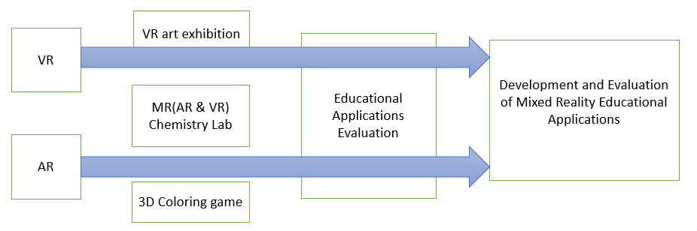

Figure1-14. Research flowchart

Ⅱ Related Work

The Camification of VR and AR contents [7] not only increases the interests of learning or training process via gamification elements, but also reinforces learners’ participation degree so as to diversify singular VR and AR content presentation form. The means of game also alleviates learners’ psychological fears before specific contents, such as insect learning [35]. Both VR and AR technology could be used by smart phone. Nowadays, higher education has listed AR and VR as next wave of teaching technology. According to the estimate of Goldman Sachs, until 2025, approximately 700 million RMB will be used in AR or VR application program development in the education field, covering the range from mechanical operation to architectural design and medical surgery simulation. The market research firm Gartner predicts that before 2021, around 60% higher educational institutions in America will employ VR technology in the teaching process. VR technology indeed has successful application cases in educational, here are some in the K12 classroom (K12 is the North American designation for primary and secondary education. The expression is a shortening of Kindergarten through 12th grade, the first and last grades of free education in the United States and English Canada). In China, more than 14 colleges and universities have their own VR Laboratory, many applications for Early Childhood Education were developed.

Under traditional education mode, the focus remains to be “reception learning”. For instance, in chemistry education, many teachers consider that students only need to learn about the basic experimental procedures and eventual experimental results. However, such practice has great limitations. The first point is the shortage of initiative. In most cases, students just passively observe how the teacher demonstrates the experiment, but have rare chances to personally operate the experiment. In this way, students could only act as passive knowledge receivers and find great difficulty in memorizing the knowledge. The second point is the limitation of experimental demonstration time because students could not repeatedly operate experiment. The third point is the shortage of reagents and high risks. Partial chemical experiment reagents and apparatuses have certain risks. As for such risky experiments with complicated experimental procedures, it is necessary for students to repeatedly familiarize experimental procedures and steps prior to operation. Above limitations restrict students’ learning effects in time and space to some extent. New technologies should be employed to change traditional education mode, and convert reception learning teaching mode to proactive explorative education mode. The prime purpose of utilizing VR and AR technology to design education games is to construct a virtual learning environment or virtual-real learning situation for learners. How to establish an effective learning environment is a key concern in the beginning of design. Schank and Kass[36] conclude three elements of an effective learning environment. The first one is to present a goal which could stimulate the momentum of learners. The second one is to place students in a real learning environment. The last one is to distribute tasks which require information analysis and design of action plans to learners.

2.1 Educational Applications types

In spite of the short term of educational application of VR and AR technology, it coincides with the opinions of educational theories such as behaviorism and constructivism. 1. In behaviorism theory, learning is stimulus-reaction connection constituted by the interrelation between knowledge and the outside world [18]. The learning environment created by VR and AR could promote learners to seek feedback from the interaction with environment and retrieve subsequent action directives so that the connection between knowledge and reaction could be fully found. 2. Considerable construction instrument systems and presentation areas provided by VR and AR virtual learning situation and learners’ subjective initiative coincide with Piaget’s conception and practice of “moving laboratory to the classroom” and the constructivism view of “learning is certain experience in real situation”. [19][20][21]. Comparing with the full-virtual VR technology, AR not only realizes simulated presentation of learning objects, but more effectively places it in the real environment and operates the model so that students have the chance to independently explore and acquire recognition in a natural interaction means. Its advantage consists in the ability to present the information that could be hardly seen in the real environment and propel the seamless connection between information and real environment. In this way, learning interactivity will be as natural as that in the real world. This point has great enlightenment meaning to the teaching of abstract contents and the improvement of learners’ interests.

The New Media Consortium（NMC）is a famous organization in the field of education. It releases a horizon report per year to introduce all major technologies which possibly produce great impacts on education. In the horizon reports released in recent few years, AR is always listed as one of the six most potential technologies in future few years. Additionally, the change of diction from “simple AR technology” to “AR technology” could prove the growing maturity of this technology. What is noteworthy is that the report in 2016 proposes VR and AR in parallel, which means that VR and AR technologies have mutually integrated in the application in education field. The application of VR and AR in the education field primarily has the following few types.

2.1.1 3D virtual learning environment

At present, the development trend of 3D virtual learning environment could be summarized by four points. The first point is user participation in creation. Users totally create learning contents on their own. The second point is to provide an explanatory space to integrate with learning management system. Sloodle (Second Life Object-Oriented Distributed Learning Environment) [28] is a typical example. To be sure, it is not perfect enough and still requires the efforts from more researchers and practitioners. The third point is the integration between virtuality and reality. The real sense in virtual environment depends on the development of graphics. However, regardless of its development prospects, virtuality is still virtuality, but the learning activity of people takes place in the real physical world as usual. “AR” enables students to have better experience in the learning activity. This is also the reason why to popularize such technology in the education field. The fourth point is to propel the in-depth integration between 3D and artificial intelligence technology (AIT). Out of the complexity of learning, it is nearly impossible for 3D virtual learning environment to entirely simulate human actions such as automatic answer-question, automatic test paper, automatic grading without any breakthroughs of AIT.

2.1.2 AR book

In the field of education, the case which firstly employs AR technology is the *Magic Book* produced by Damine Hirst [14]. By producing the 3D scene and animation in accordance with book contents and utilizing a special pair of glasses to make children see the virtual-real scene, it realizes the interactivity with dinosaurs via the book *I Dinosaur* [30] as shown in the figure. In this thesis, the author designs and develops color filling picture books. Painted pictures in the book could display the colorful 3D model after being photographed by phones [22]. The appearance of AR education games corresponds to the concept of edutainment and greatly improves the operational ability of students.



Figure2-1. I Dinosaur [31]

2.1.3 AR Science teaching

A lot of scholars have applied AR in science teaching to enhance learners’ visual perception ability in the real scene [19]. Claraval et al [20] have demonstrated a case of astronomy teaching. In AR environment, teachers and students could explore the relation between the Sun and the Earth and that between the day and night through rotating the virtual Earth. Cai Su et al [21] realize the visualization of magnetic field by combining AR with Kinect somatosensory equipment. While learning the knowledge concerning magnetic field, students could have real-time interaction with equipment by means of gestures and therefore learn about the distribution and changes of magnetic field. Researchers from Vienna University of Technology have conducted a professional dynamics teaching presentation [22] which simulates the physical test in the dynamics field via AR physical engine and meanwhile analyzes parameters of objects such as quality, stress, and motion path. However, the use of this system in teaching takes expensive helmets, 3D glasses and other equipment. Visualization of the magnetic field could make use of AR + Kinect somatosensory equipment to visualize the invisible magnetic field and excavate the interactivity of magnetic field under different conditions throughout natural interaction. As shown in the figure, when the magnet keeps moving with two hands, the magnetic induction line also keeps changing all the time.



Figure 2- 2. Physical magnetic field visualization []

The AR-based convex lens imaging experiment developed by Cai Su team from Beijing Normal University explores the influence of AR technology on Grade Eight students’ physics learning effects and deep cognition in the empirical research [23]. The AR-based convex lens imaging training aid uses three different mark cards to simulate candles, convex lens and fluorescent screen. When the camera captures the mark cards, parameters including convex lens’ 3D model, and parallel number lines used to mark the focal length and twofold focus length data will all display on the screen. By respectively placing the candle mark card and screen mark card on the two sides of convex lens mark card, the screen will automatically present relevant images on account of the distance between the candles and convex lens. If the distance between candles and convex lens is regulated, the image on the screen will have real-time changes in line with convex lens imaging principles. Supposing the object distance is u, then 1u 1 + = v 1f distance will be v and focal length will be f. By reference to the formula of convex imaging, if u < f, the optical lens will present virtual imaging; if u = f, the optical lens will not present any imaging; if u > f, the optical lens will present real imaging. As proved by the experiment results, AR has greater impacts on students with poor academic performance.



Figure 2-3 Simulated convex lens imaging []

Research findings indicate that AR instrument could help students better memorize the structure of atoms. In traditional class, students have relatively poor understanding level and memory about knowledge. However, AR-based software teaching could mobilize students’ initiative and encourage them to be more attentive. Once explicitly seeing the simulation model and the interaction effects, students would have more deep impressions on the learned knowledge. AR instrument is found to be useful in improving students’ operational ability in exploratory experiment. Comparing with the operation of keyboard, mouse and computer, AR instrument has better programming knowledge memorization effects by directly using AR technology to reinforce activity participation sense. At the same time, students also raise some suggestions for this instrument. For instance, they expect the simulation phenomenon of objects to be more vivid. Additionally, it is also feasible to turn the software more interesting by adding some cartoon or animation elements. Combining with PC or tablet teaching, AR technology could examine its influence on chemical reaction by controlling temperature, concentration, catalyst and other conditions in the means of natural interaction.



Figure 2-4. Chemical hydrogen peroxide []

Shelton et al teach knowledge concerning nine planets by AR teaching training aid to present the planets in the 3D space authentically before eyes. This technology enhances teaching interaction and teaching effects [10] as shown in Figure 2.



Figure 2-5. First person perspective of earth-sun AR exercise [50]

2.1.4 AR and VR Language teaching

Scanning cards with tablet computers or phones to discern words, and present relevant pictures or 3D models with pronunciation could help children spell vocabulary and learn pronunciation. The research shows that such learning which integrates touch sense, auditory sense and visual sense more easily stimulates children’s enthusiasm comparing with traditional teaching method and has prominent vocabulary learning effects for non-English native speakers. Using phone to scan vocabulary and present matching pictures and pronunciation also comply with children’s cognitive rules. The following figure presents the learning interface of Happy English.

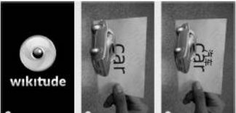

Figure 2-6. Interface of Happy English []

The VRCLASS Chocoo Interaction developed by Chocoo Company started to develop VR immersive learning system as of 2014 wherein users could stay in various scenes to personally perceive the charms of future mode of learning and communicate with long-distance teachers; teachers could fully develop the infinite potentials of virtual space and easily realize the teaching mode that could never be actualized in traditional class. In one class with 50 minutes, teachers usually make traditional teaching in former 30 minutes to lead students to spell vocabulary, such as giraffe, tiger and lion, and ask students to use VR head-mounted equipment to interact with the virtual world in the last 20 minutes. Such practice could consolidate the learning effects. While parents generally approve the efficacy of such teaching method as shown in Figure 2-7.



Figure 2-7. Coqui ABC Immersive Children’s English Learning [29]

2.1.5 VR Practical Training

The introduction of knowledge in specific scenes outside the classroom endows educational experience with unparalleled values. Students do not simply listen to class anymore, but follow the interpretation with the head-mounted equipment to obtain real experience in the virtual environment. For instance, the project in the following figure is related to the security of construction site. Virtual education expert Inge Knudsen builds up a virtual construction site. This site exist severe security problems. Whereas, students could move around in the virtual environment and take photos in safe places. Such case is nearly impossible in real life. Out of this reason, this is in particular suitable for the virtual world. Personal virtual scene allows students to have experience in any field in work or life in the learning stage.



Figure 2-8. Virtual Construction Site Program

2.1.6 Location Based AR Learning

Users could seek relevant architectures on the campus according to the real scenes captured by the camera during application use process. Once arriving at the site of target architecture, the camera could automatically discern the architecture information by capturing imaging and present the imaging to users as learning contents. Most respondents have mentioned that they could retrieve information at any time and place via phone and the combination of GPS technology and AR technology turns the search process and means of presentation more natural. It not only saves the procedure of manual input. The more important thing is that what you see is what you get. Besides, this software is acknowledged to be a feasible alternative of paper medium. Overwhelming respondents have stated the novelty and interest of the means of interaction between phone camera and real physical environment. Similarly, users propose many constructive opinions for the software, but some opinions could not be solved subject to the limited technical skills of hardware. For instance, the slow network speed of campus wireless network leads to the slow information loading speed, long-term and inaccurate phone GPS operation.

2.1.7 Other applications

The application of ChinAR [37] lowers the threshold of Chinese zither learning, and meanwhile popularizes the most ancient musical instrument in China. Regardless of the benefits of Chinese zither, I learn from the communication with classmates who teach Chinese zither in the school that overwhelming learners would give up one month later. Different from other musical instruments, Chinese zither has its own set of musical systems and learners have to learn and adapt to many new concepts and methods in the introduction stage. At this point, its introduction threshold is obviously higher than that of other musical instruments. This thesis gives lots of “hints” to beginners by way of augmented learning technology, greatly lowers the introduction learning threshold, and combines with relevant musical theories at home and abroad to design a full set of interaction methods.



Figure 2-8. Chinese Zither Application []

AR technology is capable of turning the originally boring knowledge in teaching to lively images one by one by supplementing virtual information to the real world, and improving students’ learning interests and initiative. To be specific, special geomorphology, historical figures and events and inaccessible things could be all presented before students through AR technology. As shown by VR and AR application cases introduced in the last section and the latest world-famous AR game Pokemon Go, AR is more easily commercialized than VR.

No matter what technologies and what means have been employed, people should pay attention to the integration of learning contents and game elements. Throughout systematic teaching design, the learning contents could be rationally incorporated into the task of educational games under the instruction of learning theory. Situational setting makes for building up an immersive learning situation for learners and helping students have meaningful knowledge construction and exploratory learning.

2.2 Interaction Design

2.2.1 The develop of HCI

HCI (Human Computer Interaction) refers to the information exchange between man and computer, including the information provided by computer for people by inputting or displaying equipment, and the manual operation of inputting relevant information to the computer by input equipment. The purpose of man-machine interaction is to discuss how to make the designed computer help people more reliably and more effectively complete tasks. It mainly undergoes three stages.

1, Linguistic User Interface

Low efficiency. Man-machine came into being since the appearance of the first computer ENIAC in the world. Its operating system was completed under directives. At that time, it brought about more sense of mystery of people to computer, and language obstacles impressed people with strong sense of professionalism. Therefore, people needed to proficiently command one computer language for fear of the low-efficiency interaction process.

2, Graphical User Interface

Strong operability. Graphical user interface is the mainstream category of user interface represented by American Microsoft. It fundamentally changes the routine which takes substantial linguistic forms in the past. One common feature of existing graphical user interfaces is to convey and display information via the window and operate by keyboard and mouse. Since graphical user interface relies on visual recognition and manual control in man-machine interaction process to a large extent, this interface has strong operability.

3, Multi-media User Interface

Multi-media technology is a kind of transitional technology prior to the advent of natural interaction design technology. Before the invention of multi-media user interface, user interface design has completed the transition from language to graph. However, along with the development of multi-media technology, animation, audio and video media have been gradually introduced into this technology. Especially, the introduction of audio and video media enriches the presentation form of information communication via the computer, creates good conditions for people to well control and convey information and greatly elevates man-machine interaction efficiency. In man-machine interaction, multi-media user interface has an advantage in increasing people’s identification and choices for information. Moreover, a great process has been made in the presentation form and interaction degree with man of computer information communication.

Accompanied by the further advancement of computer technology, information technology and network technology, new interaction technologies and user interface forms such as automatic speech recognition (ASR), glove and other sensors, gesture recognition, hand shank operation, and eye tracking continually spring up.

2.2.2 Interaction Design for VR and AR

As of 2014, the publication of VR entertainment equipment such as Oculus, Gear VR, and HTC Vive makes VR technology serve for ordinary consumers. People have entered a new age of man-machine interaction. Computer creates a simulated real 3D world for users by visual sense, auditory sense, tactile sense and other perception simulated technologies Users are not isolated individuals anymore but turn a part of the virtual environment. Man has established a natural connection with machine [10].

There are diverse VR interaction modes. At present, VR interaction modes primarily include the following seven categories. 1. **Gesture Tracking**: As a kind of mode of interaction, gesture tracking could be divided into optical tracking such as in-depth sensors like Leap Motion and NimbleVR, and data glove which wears sensor on the hand. Microsoft HoloLens is an AR hardware which utilizes gesture in interaction. Once wearing HoloLens glasses, users could control virtual objects and function menu by clicking, dragging and stretching with fingers in the air, such as posing Air tap gesture to open holographic figure or posing Bloom to open the start menu. 2. **Motion Capture**: Whole-body motion capture is not necessary in many scenes. Its problem consists in the shortage of feedback. In consequence, users could hardly perceive the efficiency of their own operation. 3. **Tactile Feedback**. Tactile feedback primarily refers to button and vibration feedback. Next, this section will make a brief introduction to VR hand shank. Nowadays, three leading VR head-mounted manufacturers Oculus, Sony and HTC Valve unanimously adopt the VR hand shank as a standard interaction mode. The so-called VR hand shank is actually a hand shank with two separate handles, tracking function in six free degrees of freedom (including three rotational freedom and three translational freedom), button and vibration functions. 4. **Eye Tracking**: Palmer Laci, founder of Oculus has credited it as the “core of VR” because it could provide optimal 3D effects from current angle based on the inspection of human eye position. Therefore, VR head-mounted imaging appears to be more natural out of its less probability of hysteresis and great entertainment. In the eyes of most VR practitioners, eye tracking technology has become an important technical breakthrough in solving VR helmet dizziness. VR head-mounted FOVE in Japan has already introduced this eye tracking technology. 5. **Voice Interaction**: although gesture operation relieves the two hands, it still has lethal shortcomings – frequent hand raising gesture would cause arm arching. At present, Microsoft Cortana, Google Now, Apple Siri, Amazon Echo are all excellent speech recognition helpers. However, due to their low recognition rate, they could only work as auxiliary operation instrument and corresponding intelligence degree can never reach up to the requirement of AR interaction. By means of speech control, users and the world that they are observing would not interfere each other. More importantly, the voice interaction between users and VR world would turn more natural since users could realize communication in any place and any corner and even do not need to move their heads to seek. 6. **Sensor.** Sensor could help people naturally interact with the multi-dimensional VR information environment. For instance, Virtuix，Cyberith and domestic KAT all commit to the research and development of universal treadmill. Likewise, people who wear whole-body VR suit Teslasuit could personally perceive the changes in VR environment, including the breeze, and even the sense of being struck by a bullet in shooting games. All of these perceptions generate via sensors on the equipment, such as smart sensor ring, temperature sensor, photosensor, pressure sensor, and visual sensor. Such sensors simulate the skin to produce corresponding feelings via pulse current, or convey all sorts of perceptions like tactile sense and olfactory sense to the brain. 7. **VR Theme Park**: VR theme park The Void exactly adopts this means to construct the virtual world on the physical world so that users could perceive surrounding objects and use real props like hand lamps, sword, gun, and so forth.

Therefore, VR input mode is not unified, and interaction mode is also rather diversified. In practical application, the most practical means is to customize the most appropriate mode of interaction according to the features of application.

2.2.3 User Interface Design for VR and AR

CUI design needs to consider how to better present the information and create convenience for browsing and interaction. At present, the generally used user interface is flat interface design and people could hardly break up the hard in the short run. As a consequence, it could be also used in AR and VR interface. The advantage of flat design is its ability to (1) better present contents and data and avoid the interference caused by multiple visual elements to information discrimination; (2) cater for transparency effects convenient for users’ observation of outdoor environment. Taking Google tilt brush for example, it is a color picker provided by the software similar to commonplace desktop software (in flat style). Instead, it does not a box of “paint” for slow color modulation.



Figure 2-9. Flat Design User interface in Google tilt brush []

Ⅲ. VR Art Exhibition

Virtual Reality (VR) is widely used in various fields, and it is expanding game movie towards health care, business software, education and web service. Especially various researches are being conducted in the field of exhibition, and methods for implementing Attachable-removable HMD (Head Mounted Display) VR contents using a smart phone are being presented. The VR technology in the field of exhibition solves both the time, space constraints and the unilateral information transfer to the exhibitions displayed in the offline exhibition. The advantage has that this can overcome the quantity, time and the geographical constraints that should be met by direct visits. This paper presents a method to overcome the limitation of time, space, unidirectional information in offline exhibition, and also presents a new method that utilize multimedia visual design works as VR contents. The virtual art exhibition application can allow users to appreciate art works at any time without leaving home, which breaks the time and space constraints.

3.1 Game Design

According to the role of this game, we choose the virtual presentation mode of Mobile + VR. Among the Mobile + VR devices, the Samsung Gear VR indeed has better leak-proofness, but you must have one of the latest Samsung phones such as the Galaxy S6, Galaxy S6 edge, Galaxy Note4, Galaxy Note5, and Galaxy S6 edge+. Google Cardboard has the same experience, the cost is relatively low, and both Android and Apple iOS system are supported, so that it can be used on most mobile phones, it is a good choice as a VR entry-level experience. In the Google Cardboard introduction page, there is such a sentence "Experience virtual reality in a simple, fun, and affordable way" summed up Google Cardboard has the following advantages compared to other mobile VR products: 1, cheap, 2, easy to carry, 3, while supporting both Android and IOS phones with appropriate screen size. Therefore, this game we have selected Google Cardboard as a game device. Users can also assemble Google Cardboard according to the introduction. The assembly diagram is as shown below.



Figure 3-1. Google Cardboard []

This application is a multimedia mobile visual VR application using Google Cardboard. Users can experience the virtual art exhibition from the first-person view. Because the interaction ways that supported by Google Cardboard and mobile phones are very simple and limited, we have used users’ gaze direction to control the direction the user want to move toward. After the application starts, the character moves in the direction of the user's gazing direction and stops when it enters a certain distance in front of the painting or the obstacle. The user can watch the painting and continue to move by changing the gazing direction.

3.1.1 Composition of contents

Different from the actual exhibition halls, the most important thing is to ensure the distortion of the Virtual Reality visual contents are minimized, so that can improve the users’ subjective initiative and immersive sense. Flexible use of virtual reality display technology and analysis of visual content from an aesthetic perspective. It is also important to decorate the display environment as real as possible. The digital exhibition works was obtained by the basic offline exhibitions. There are totally of seven art works in this application. Figure 3-2 are shown 3 of them.

  

(a) [54] (b) [55] (c) [56]

Figure 3-2. Works of Art

3.1.2 Immersion for VR exhibition

In this section, we explain various analytical methods to increase the immersive and experiential factors by moving multimedia visual design contents that presented in offline exhibition to virtual reality. The HMD devices basically has a characteristic that provides experience and immersion. However, when the offline content is changed to digital content, it is assumed that the problem raised in the previous is to be solved in this paper. Focusing on enhancing immersion and experiential factors through solving these problems. In particular, [] defines the disturbing elements as follows. "It was pointed out that if the display image size was small, and the stereoscopic effect was low, the motion was not reflected properly, cannot obtain a complete immersion. The lower the resolution of the screen support lower the immersion. " On the experiential side, the obstacle to HMD immersion is "I can move freely, but the result of the movement cannot be visually reproduced similar to reality". Based on the problems raised above. As shown in Table 3-1, we suggest solutions for enhancing experiential factors and immersion.

Table 3-1: Influencing Factors of Immersion in Virtual Reality Display

|  |  |
| --- | --- |
| Division | Experience and immersion factors |
| Display Performance | Contrast ratio, color recall, color depth, color temperature, Gamma curve, Luminance |
| Image Resolution | Difference in image resolution. |
| Image Size | Difference in image size when using HMD device. |
| Exhibition layout | Shading and shadow effects |

The elements that can enhance the immersion feeling to show the intention of the artist in the exhibition works can be judged to be the degree of experience that stimulates the elevated enjoyment, and curiosity. In exhibition works, such factors as color and layout can be considered according to the artist's intention, but it is difficult to apply it to the overall works. For this purpose, the proposed method in Table 1, that through create an exhibition environment, active experience of multimedia visual contents can be enhanced as an experiential factor.

3.1.3 Interaction Design and Operating Mode

In terms of user interaction, in order to use Google Cardboard as a tool to implement multimedia exhibits, the interaction mode is particularly important, especially if you want to approach the actual exhibition, the interaction mode must follow the natural interaction as much as possible, through analysis of the hardware conditions of Google Cardboard, Using the way of the user's FPV to interact, the user in the virtual world automatically advances toward the direction, and stops when entering a certain range near the art works or obstacles. At this time, the user may stop to view the painting or walk away by change the direction of view to change the direction of movement.

3.2 Implementation

This application uses Unity 3D 5.1 as a development tool. Unity has built-in support for virtual reality from 5.1. Download CardboardSdkForUnity. Packadge and import it into Unity project. In the hierarchy panel, use Cardboard Main Prefab instead of standard camera, check the Virtual Reality Supported option in project setting, and then the game can be switched to VR mode preview. The following is the main code for the user to move and determine the obstacle part:

float walk_speed = 2;

void Update() {

Ray ray= new Ray(); // Create ray

RaycastHit hit; // Collision

if (Raycast) //Collision check

{

Transform.translate(forward, walk_speed); // forwarding

float distance = vector3(position.hit, position); // calculate distance

if (distance < 3) {

_speed = 0 ;

} // check distance to wall walk

else {

walk_speed =1;

}

}

}

The application development environment is Windows 10 64bit, Unity3D 5.1, and the development language is C#. The hardware devices are Google Cardboard and Samsung S4 smart phones. The following figure shows the program execution scenes and various visual design contents in a virtual environment. The effect and experience are not inferior to those in the reality world exhibition hall.



(a) The Art Exhibition Room



(b) The Art work shows in front of user

Figure 3-2. Game Scenes

3.3 Conclusion

The virtual display application is the trend of the development of artistic activities. It breaks through the limitations of time and space. With virtual reality technology, designers can build virtual exhibition space according to their own creativity. Users can observe the work from any angle. The organizer can update the display content at any time. Nowadays, smart phones have become popular and become our daily necessities. You can easily use a variety of applications through your smart phone. With Google Cardboard and smart phones, allows people who are passionate about art appreciation to visit art exhibitions anytime and anywhere. This research analyzes the factors that affect user experience and immersion, explores the design of virtual reality art in the display environment of new media art, and can better reflect the Combine of science and technology and art. Serving society in a wider range and based on existing conditions proposed ways to improve user experience and immersion.

Ⅳ. AR 3D Coloring game

At present, augmented reality technology has begun trial application in military, medical, commercial, education, and maritime training and achieved certain results. The combination of education and AR technology brings about innovative development in education [5]. The previous chapter introduced the application of AR in books. Based on the description of the features of augmented reality technology and the application of augmented reality technology in education, this article developed "Color The Earth" - a fun coloring application for the earth and "Color Xi Xi" - a cartoon character. The Color The Earth aims to help young children understand their distribution and position by coloring the outlines of oceans and continents, and to recognize the movement of celestial bodies through the three-dimensional dynamic representation of the models of the Earth and the solar system. The laws and knowledge. "Color Xi Xi" enhances young children's perception of color through an easy coloring process. This chapter makes a more detailed analysis of the characteristics of augmented reality applications, product design and implementation technologies. These two AR games enable users to “move on a piece of paper” a planar picture through a simple and portable mobile terminal scan. Multiple forms of interaction also stimulate the interest of learners and enable them to interact with three-dimensional “buddies”. Learn knowledge and understand the world. Break through the limitations of paper books, promote the acquisition and absorption of knowledge, improve the interactive effect of teaching, and fit in with the concept of entertaining, improving the students' ability to operate, identify and identify colors. Augmented Reality As an emerging learning medium, e-books will have a disruptive impact on the classroom environment, the teaching model, and even the education field.

4.1 Game Design

AR technology is a combination of virtual image and reality. Interaction should be the main focus of AR. However, due to the fact that smart glasses are not formally launched, AR technology still stays on the screen of mobile devices, resulting in many AR technologies. As a gimmick, AR applications are still mainly based on acceptance visual experience. Coloring AR products are a few successful products in the current AR market. They have the following characteristics: high interactivity and entertainment; they can be used independently or as As part of the system, there is less investment in traditional games; collaboration between different domains is required, and map matching UV matching requires a higher level of computation. Color rendering AR two ways of expression: 1, real-time rendering model texture content; 2, only once the model texture is specified without rendering content in real time.

4.1.1 Color the Earth AR

The application is used by aligning the camera of the mobile phone with the picture of the coloring paper on the paper book. The recognition map in the screen shows red until the recognition picture is completely contained in the scanning frame on the screen. The recognition is successful. The recognition map turns green, and the three-dimensional effect of the earth object appears on the screen. Clicking on the earth model on the screen can interact with the model. The first click on the earth-earth model rotates, the second solar system appears when the entire solar system is clicked, and the game is played. The flow chart is shown in the figure below.



Figure 4-1. The playing flow chart

4.1.2 Color Xi Xi AR

This application can be run on mobile devices, easy to operate, and highly mobile, with just a few pieces of paper or cards to experience anytime, anywhere. The design motivation of this app is to help children understand the colors and express their desired mix through coloring and collage. Young children can also observe their designs and collocations from all angles. Using the camera of the mobile terminal (mobile phone) to scan and identify Figure 1, the original color character model will be displayed on the top of the identification map. This model is for children to provide reference, and then after identifying the color on Figure 2, it will be scanned to identify Figure 4-2. In the upper part of the picture, a three-dimensional model after the user has filled in color is displayed.



Figure 4-2. The playing flow chart

4.2 Implementation

Recognition maps and models are the main components of painting-type AR applications, and letting them connect requires UV splitting and matching. UV: is a two-dimensional texture coordinate point that resides on the vertices of a polygon mesh. They define a two-dimensional texture coordinate system called a UV texture space. This space defines the axes with two U and V letters. Used to determine how to place a texture image on a three-dimensional model surface. UV is the mapping of the map to the model's coordinates. In addition, the prepared AR identification map needs to be uploaded to the Vuforia website for identification and certification before it can be downloaded and used. Then, the position of the identification map and the model is integrated in the Unity game editor, and the color of the identification map is obtained through the screen capture. The Shader parameter is passed to the corresponding position of the model. Finally, the painted 3D model is displayed at the top of the picture. The production flow chart is as follows.

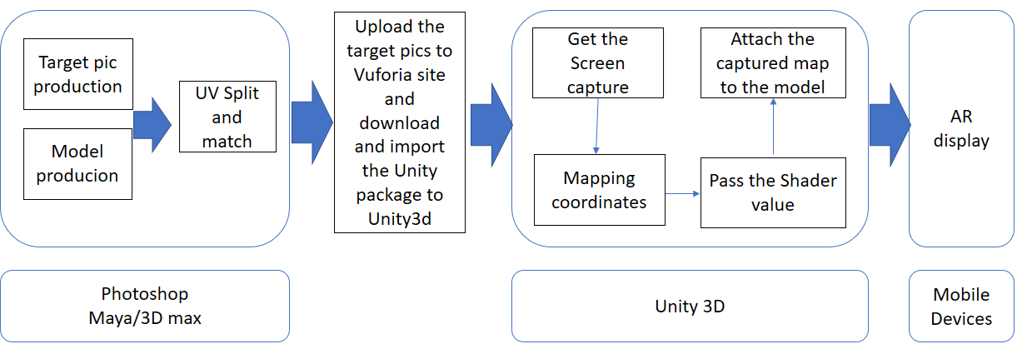

Figure 4-3. 流程图

Color the earth AR and Color XiXi belong to the coloring class AR application, and are implemented according to the flow chart shown in Figure 4-3 in the above figure. The two specific application production processes and steps are described below.

4.2.1 Color the Earth AR

First of all, the software used to implement the Color the earth AR application is: PhotoShop CS5 to create plane recognition maps, Maya to create Earth and celestial models, and Unity3d to integrate all resources and add control code.

• Recognition map production

Need to make two pictures, the first picture is shown in Figure 4-5 (a) is used to identify the card, the middle of the earth is no structure, if you add content, black lines will become part of the identification information, color recognition affects the recognition rate While the white part has no identification information, the second figure is used for reference for modeling and for UV positioning and matching, which is also the identification map that the user eventually obtains. In addition, during the production, it is necessary to consider the perspective of using the model. In general, the user will look at the model from the top and the front of the model. As shown in the figure, consider the parts of the model that are likely to attract the attention of the user, such as the top of the model, and try to Reduce stretch. In the part that cannot be seen by the user, as shown in the figure, it is possible to reduce the number of details of these parts, but it is also necessary to make a part that cannot be seen in the beauty of the model.

 

（a） (b)

Figure 4-5. AR 识别图

 

（a） 俯视图 (b) 正视图

Figure 4-6. AR 识别图

 

Figure 4-7.阴影部分为模型中几乎看不到的部分

• Modeling

Modeling should match with the identification map as much as possible. The globe uses some basic geometry such as spheres and cylinders, or through the deformed geometry of the basic model, divides the functionally different models into separate objects. In addition, the angle of the model that can be easily seen when using the model should be considered. In general, the easy-to-see angles are the top and frontal angles. Consider the parts of the model that are easy to attract people's attention. Minimize the texture stretching to ensure the plane graphics. Can show better picture effect, make a good model as shown. The MAYA makes three important operations of the model: freezing the transformation, deleting the history, and returning the coordinate axis to the center of the object.

 

Figure 4-8.Maya地球模型

• UV split match recognition map

This step is a bit cumbersome and cumbersome. The concept of UV introduced in the previous section. UV is actually a kind of plane coordinate. The correspondence between the points on the model in the plane is the position in the plane coordinates. UV split matching directly affects whether or not Can complete the matching model and picture stretching, in the coloring category, although you can not avoid stretching, but try to distribute as much as possible to reduce the stretching situation, or put the stretched part unobtrusive The place (such as the bottom of the model) is shown in the figure. The UV is divided into different parts of the model to separate the UV, and the UV is matched with the model on the picture. The part of the UV that is not easy to see can be reduced and overlapped with other parts. The following figure shows the comparison of UV coordinates and screen coordinates.

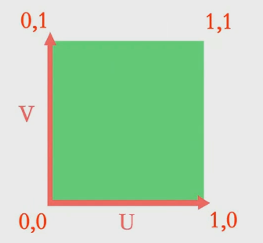 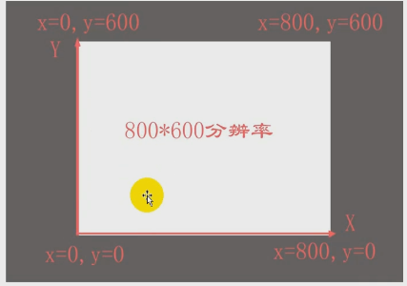

Figure 4-9



(a)



(b)



Figure 4-10. 地球仪框部分的UV匹配

• Vuforia configuration

The mobile terminal AR development SDK is provided on the Vuforia website. After a user uploads a picture to a website, the website will register the identification of the identification map according to the color and outline of the picture. As shown in the following figure, the recognition map in this application is five stars.



Figure 4-10. 地球仪框部分的UV匹配



Figure

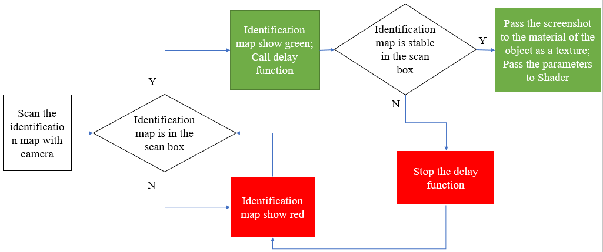

Figure 4-4. The flow chart of this application



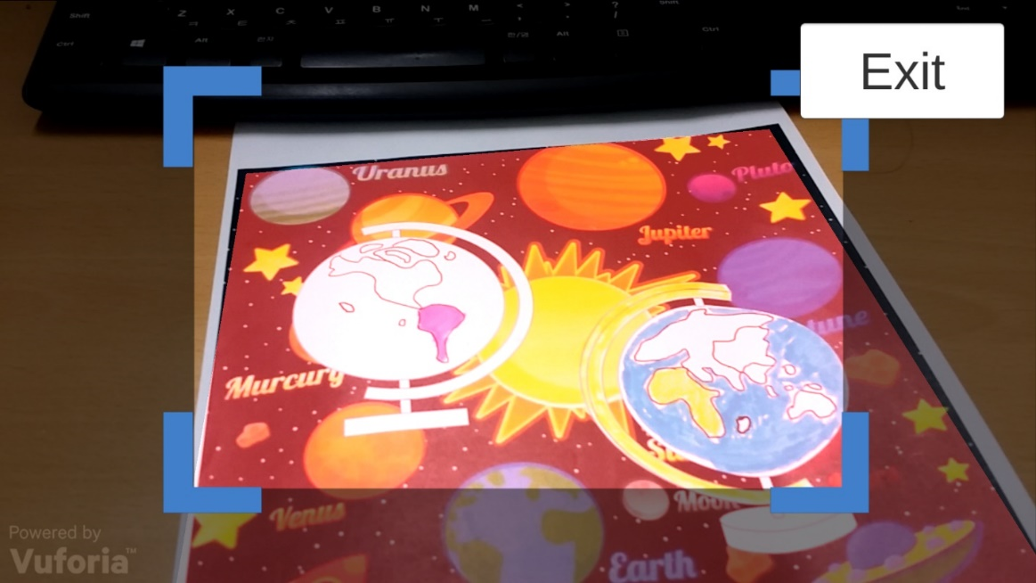

(a)

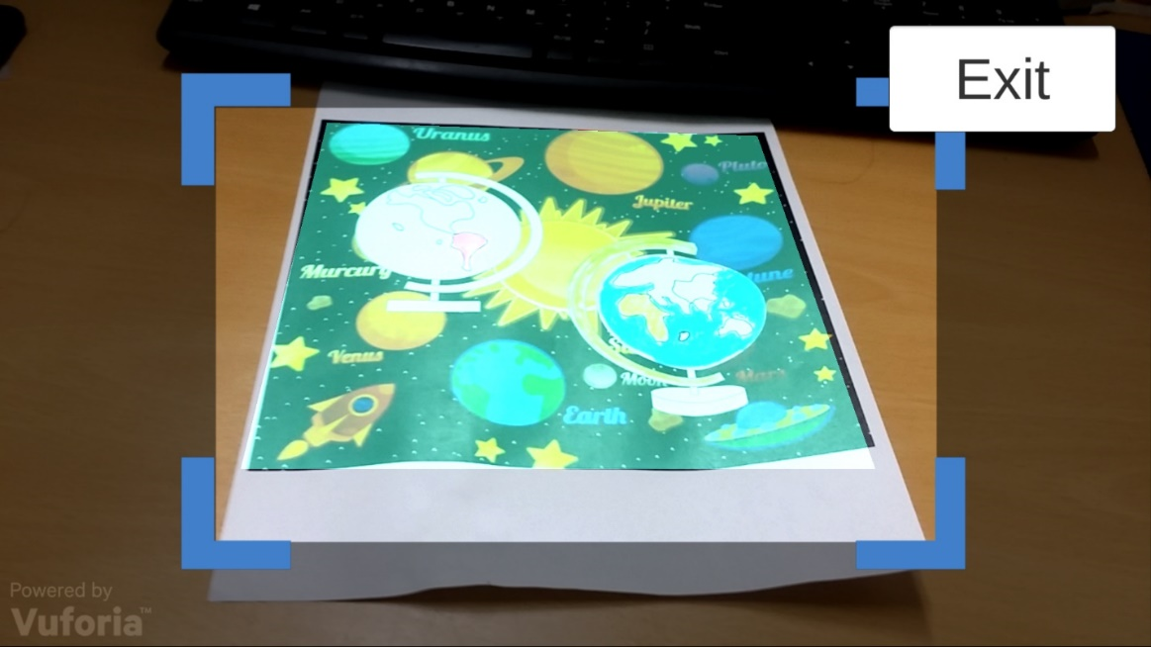

(b)

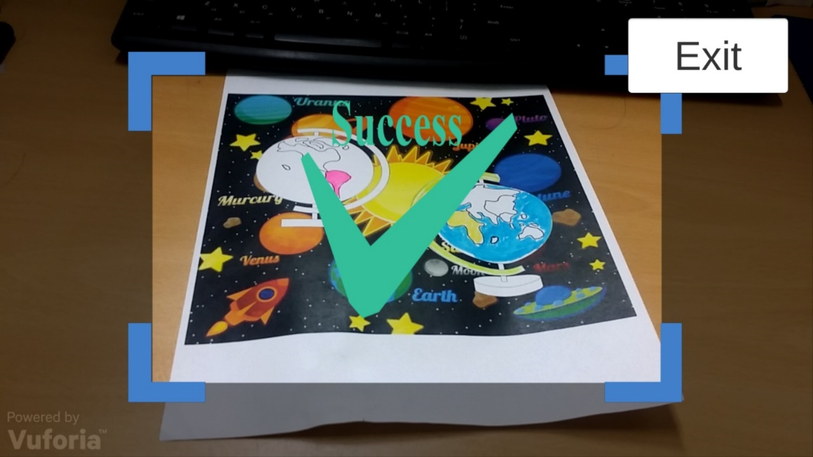

(c)

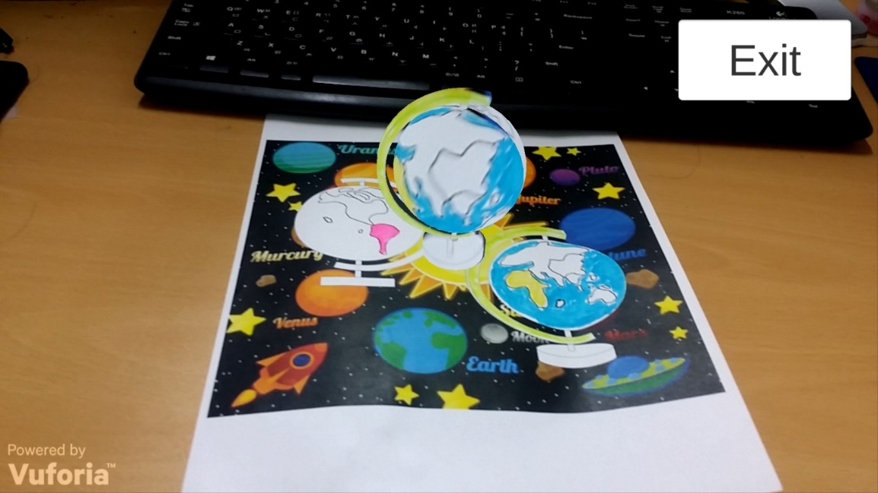

(d)

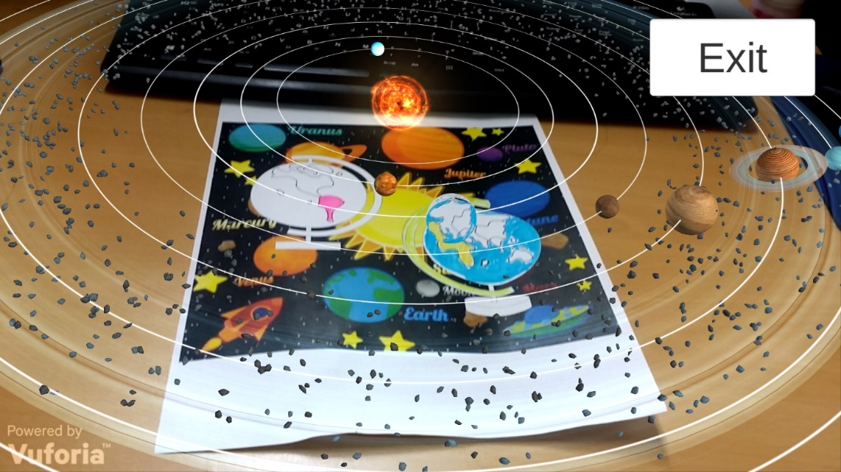

(e)

Figure 4-5. Game scenes

4.2.2 Color Xi Xi AR

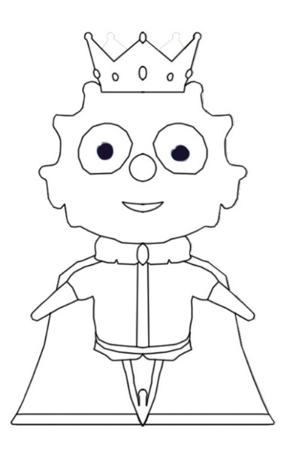 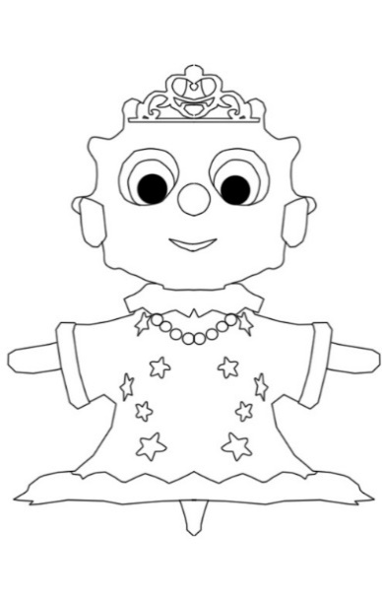

Figure 4-2. Two characters’ original sketch

  

1. (b) (c)

Figure 4-3. The AR Scene(a)and (b); the AR+ Scene (c)

halfSize = new Vector2(gameObject.GetComponent<MeshFilter>().mesh.bounds.size.x,

gameObject.GetComponent<MeshFilter>().mesh.bounds.size.z) * 50.0f*0.5f;

targetAnglePoint1 = transform.parent.position + new Vector3(-halfSize.x, 0, halfSize.y);

targetAnglePoint2 = transform.parent.position + new Vector3(-halfSize.x, 0, -halfSize.y);

targetAnglePoint3 = transform.parent.position + new Vector3(halfSize.x, 0, halfSize.y);

targetAnglePoint4 = transform.parent.position + new Vector3(halfSize.x, 0, -halfSize.y);

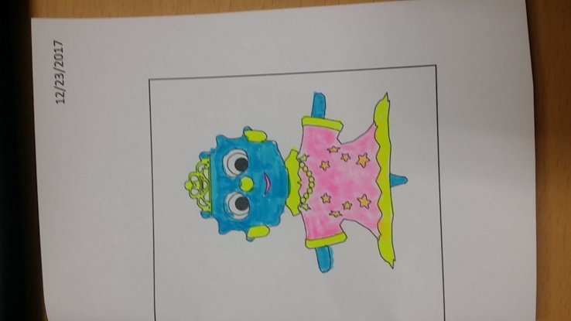 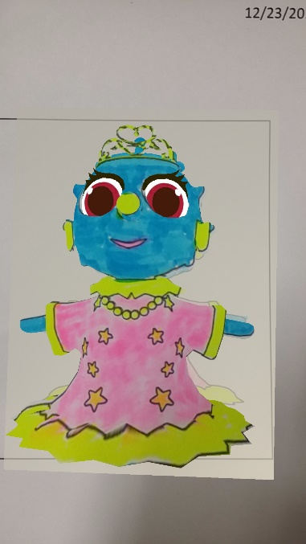 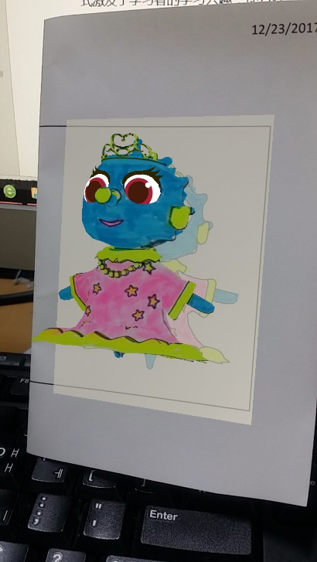

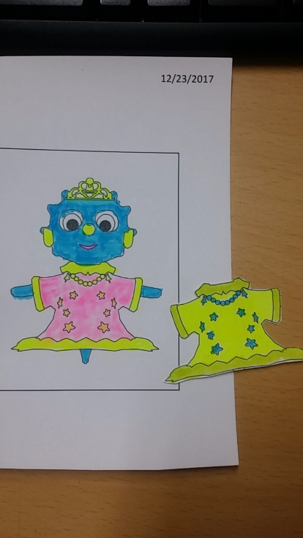 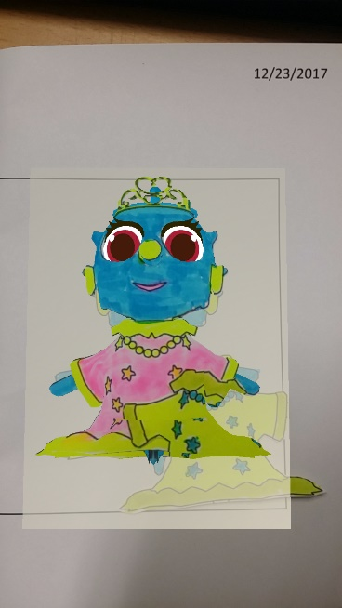 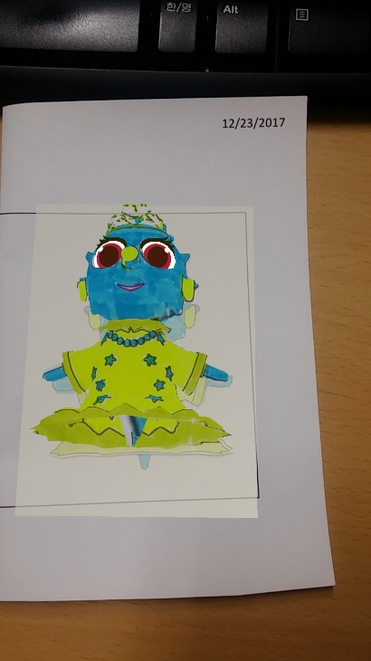

4.4 Conclusion

According to the application characteristics of AR in the field of education: that is, the concept of inquiry-based education, attract children to participate in teaching from the form of expression, and enhance the interest in things, so as to explore and research more in-depth contents in an interactive manner. The multi-media approach is more expressive, and after being integrated into augmented reality technology, the content of the teaching is expressed in pictures, videos, animations, etc., making it easier to understand. The new interactive experience, augmented with the unique interactive experience of real life, allows children to use their eyes, ears, hands, and brains to truly realize diversified education.

The application of augmented reality technology in education provides new ideas for teaching and learning. The application of coloring can be said to be its representative application. The AR 3D e-book breaks through the limitations of paper books and provides learners with realistic and intuitive simulations. Learning materials promote the acquisition and absorption of knowledge. Through the simple and convenient scanning of the mobile terminal, the planarized object can be “moved on paper”. The interactive form stimulates the learner's interest in learning and enables them to learn knowledge and understand the world in the interaction with the concept of three-dimensionality. In Color the Earth application, young children improve their hands-on ability and understanding of colors through hand-painted colors, and more importantly, through the combination of educational content, young children have a preliminary understanding of the movement of the earth and celestial bodies and stimulate exploration. interest. The Color XiXi application also has a more sensitive understanding of colors, but also allows children to enjoy the fun of matching costume colors. Of course, AR 3D e-books are in the development stage. Whether it is the fidelity or interactive effect of 3D models, there are deficiencies, which need to be further improved in the later research and production. With the advancement of smart classrooms and digital learning, AR 3D e-books as new learning media will have a disruptive impact on the classroom environment, teaching model, and even education.

Ⅴ MR Chemistry Lab

Through virtual chemical experiment equipment, students can perform simulation experiments in a high immersive environment, familiarize themselves with experimental procedures, observe and record experimental phenomena, save reagents, reduce danger, and achieve the goal of learning at any time.

The conventional education system modes are primarily passive or receptive learning style, many teachers think that students learned the experimental principle and method is important and enough, so they no need to do many experiments, according to our research, present teaching methods have limits shows as below: First: Lack of motivation and of activity, students are shown the experiments results instead of probing the results. Second: Temporal and spatial constraints; students cannot do the experiments anytime and anywhere for the limits of objective conditions and cannot repeat the experiment steps. Third: Wasted reagents and danger, some of the reagents are dangerous, therefore many practices are requisite before using the real ones. In this way can save the reagents and lessen the danger. To break the limits as we build up this application, use this can let the users practice the experiments wherever and whenever they need in a more active and probing learning way, and can also can save the reagents and lessen the danger probability. Meanwhile compare to the general 2D chemistry applications it guarantees the immersion almost alike the real world, in addition we also design a feature that users can see the microcosmic things like molecular structure using mark AR. All the solutions are confirmed Improved learning efficiency.

Chemistry VR Lab is an educational experience that can virtually simulate lab procedures and important lab safety measures. The user is immediately immersed inside a Virtual Reality laboratory and can begin walking around using the Oculus HMD to interact with the environment. There are lab procedures and safety guides spread across the tables, and a great deal of lab equipment that can be picked up, placed, thrown, or actually used in real lab procedures.

5.1 Game Design

The chemical knowledge involved in this application is a simple chemical experiment. Observe that one substance can produce other substances through chemical experiments. Through this experiment, we first understand what chemical experiments are. The experimental phenomenon: intense burning, emitting dazzling light, taking a lot of white smoke, generate white solids. The effect of the dazzling white light emitted when the magnesium bar burned was achieved by a particle system. The burned magnesium bar was placed in a beaker containing acetic acid. The magnesium bar was gradually dissolved without bubbles; the unburnt magnesium bar was put in the same package. In beakers with acetic acid, magnesium strips were observed to gradually dissolve, and bubbles were generated in the beaker.

The experimental principles and reaction equations involved are as follows: The combustion reaction of the magnesium strip changes the arrangement of the atoms.

2Mg+O2——ignite——2MgO  (1)

Mg + 2CH3COOH ——(CH3COO)2Mg + H2（ ↑ ） (2)

2CH3COOH+MgO=(CH3COO)2Mg+H2O (3)

(1) Magnesium is ignited under oxygen and burned to generate magnesium oxide.

(2) Magnesium Rod Produces Magnesium Acetate and Hydrogen in Acetic Acid Solution.

(3) Magnesium oxide produces magnesium acetate and water in acetic acid solution.

According to the education content described above, two implementation methods are adopted: Mobile + PC + Leap Motion and PC + Oculus HMD. When running on Android phones, you need to use Leap Motion's gesture recognition to interact and implement the experiment process. However, since Leap Motion doesn't yet support running directly on the phone, we use Unity 3d Engine + Remote, which is the Unity Remote function that runs on Unity in the PC and is displayed on the phone screen. In order to achieve the combination of virtual reality and Leap Motion. it is divided into AR part and VR part, VR part is virtual chemistry experiment, and there are three experiments designed. Due to the model and some experimental effects, we only test the first experiment, which is the “burning of magnesium bar” experiment. In the AR section, the atomic card is scanned to show the model diagram inside the atom. Under the condition of PC and Oculus, the experiment was performed through the Oculus handle Controllers, and the virtual reality screen was displayed through the HMD. The detailed design are as follows.

The first step is to actually put on your Oculus HMD and hold the handle Controllers on your hands. After that, it's free reign over lab experiments. For example, it's completely possible for the user to grab a paper that show the introduction on it or a match, and then place the match stand on the alcohol burner, the alcohol will be on fire, place the magnesium rods on the fire, and watch the phenomenon.

5.1.1 Leap Motion



Figure 5-1. The Design Flowchart

The program has three scenes, Main scene, Virtual Reality scene and Augmented Reality scene. Experiments are carried out in a virtual reality scene. In Experiment 1, there is an experiment table with experimental information cards, alcohol lamps, beakers, and magnesium bars. Wait. As shown in Fig 5-2.



Figure 5- 2. Main UI scene and the chemistry lab desk



Figure 5-3. chemistry experiment scene

Experiment 1 ：Burning of magnesium strip

Before the experiment, it is necessary to perform the following operations: Since the magnesium strip has a layer of oxidized MgO on it, the melting point is very high and the magnesium strip is not visible. Therefore, the surface of the magnesium strip needs to be sanded before the experiment to remove the oxide film. The silvery white magnesium bar; the asbestos mesh on the lab table to prevent the product from splashing down after burning, and the asbestos web is also provided on the test bench in the scene. According to the two implementation methods used in this application, the operation steps are slightly different.

5.1.1.1 The experience1 process using Leap Motion, PC and Mobile

* Read the guidelines or videos on the desk (mark AR)
* Grab the match on the desk and Lighting alcohol lamp
* Use a pair of tweezers to clip one of the two magnesium strips on the table and burn one on the alcohol lamp
* Watch and record the phenomenon
* Put the burned magnesium strips in a beaker containing vinegar, Put the other(unburned) magnesium strips in a beaker containing vinegar
* See and record the phenomenon
* Extinguishing alcohol lamp

5.1.2 Oculus HMD

In the case of using the Oculus HMD and Controllers, it is divided into the Main scene and the ChemVR scene. In the Main scene, the main function is to select experiments and recognize the atomic structure model of the necessary elements in the periodic table, as shown in Fig. the middle of the scene. Periodic table of elements, the user can use the handle to control the cursor to select the experiment in the left menu bar, the corresponding experimental information and description will appear on the right display box, at the same time, the elements involved in the experiment will be highlighted, the user through the operator The handle on the handle can be pointed at the element to handle the element's atomic structure model with the handle pulled to the eye, as shown in Figure 5-4.



Figure 5-4. Main scene

After you have finished observing the experiment information, select the experiment to be performed. Click the Go button to jump to the lab scene ChemVR under the ChemVR scene. The same UI layout, the left is the experimental information menu, click, the corresponding information appears in the middle panel. The user is in front of the experiment console, as shown in Fig. The user can refer to the displayed experimental procedure to start the experiment and observe the phenomenon.



Figure 5-6. ChemVR Scene



Figure 5-7. The Experiment desk

5.1.2.1 The Experience1 process using Oculus HMD

* Choose the experience1 in main scene.
* Read the guidelines or videos on the desk
* Grab the match on the desk and Lighting alcohol lamp
* Use a pair of tweezers to clip one of the two magnesium strips on the table and burn one on the alcohol lamp
* Watch and record the phenomenon
* Put the burned magnesium strips in a beaker containing vinegar, Put the other(unburned) magnesium strips in a beaker containing vinegar
* See and record the phenomenon
* Extinguishing alcohol lamp

5.2 Implementation

When use Leap Motion as the interaction tool, users’ hand is recognized as the figure below.



Figure 5-8. Hand control with Leap Motion

Although Leap Motion currently does not support the direct link to the PC, the way to achieve Leap Motion and PC link is through the wireless network protocol linking the PC side as the server side, the mobile side as the client, running the program on the PC and the mobile phone at the same time, gesture recognition information passed The network protocol is transmitted to the PC for processing. Although this method realizes wireless connection and the mobile phone has certain mobility, it still cannot get rid of the PC. Therefore, the application is directly run in Unity, and the virtual mobile phone screen is used to implement virtualization. Real mode shows the game operation screen and the operation of leap Motion.

When use Oculus as the interaction tool. Oculus uses the Oculus as the interaction tool. Oculus controls the input by the handle, the left and right handles each have two buttons, a remote controller, a touch panel, and two trigger buttons. The left controller has a menu button, which is used to pause the game. In the game, the right controller has a main interface button, which is used to exit the game interface and return to the Oculus main interface. Each key corresponds to the following name.



Figure 6-9. Hand control with Leap Motion

In the experiment, grab the operation by manipulating Axis1D.PrimaryHandTrigger, and use the Axis2D.PrimaryThumbstick to get the zoom in and out of the object, select the menu through the rays released by the Touch, and then click the button Button.One to confirm the menu.

5.2.1 Leap Motion

First, set up three scenarios and switch between scenes with the following code.

public class UIManager : MonoBehaviour {

public Button btn_Ar;

public Button btn_Vr;

// Use this for initialization

void Start () {

if (btn_Ar != null)

btn_Ar.onClick.AddListener(OnClickAr);

if (btn_Vr != null)

btn_Vr.onClick.AddListener(OnClickVr);

}

void OnClickAr()

{

SceneManager.LoadScene("ARPlayer");

}

void OnClickVr()

{

SceneManager.LoadScene("LeapVR");

}

}

LeapMotionMain.cs that control the generate of the Magnesium Rods.

private void SpawnManesiumRod()

{

if (magnesiumPrefab != null)

{

GameObject ma = Instantiate(magnesiumPrefab) as GameObject;

MagnesiumRod = ma;

MagnesiumRod.name = "MagnesiumRod";

MagnesiumRod.transform.localScale = Vector3.one;

MagnesiumRod.transform.localPosition = new Vector3(0.094f, 0.7f, 0.33f);

MagnesiumRod.transform.localRotation = Quaternion.Euler (Vector3.zero);

MagnesiumFire = MagnesiumRod.transform.Find ("FlareMobile").gameObject;

InteractionManager.instance.RegisterInteractionBehaviour(MagnesiumRod.GetComponent<InteractionBehaviour>());

}

}

Download and install Leapmotion. I currently use the Leap Motion Unity package LeapMotion _CoreAssets _4.1.6.unitypackage, unity version 2017.1.1, using the latest Unity development kits need to use Unity version 5.5 or later, otherwise it will give an error. In our project, import the LeapMotion SDK. Next we can create a hand, find LeapMotion-Prefabs-LeapHandController to drag it to the scene (this is the hand controller), find LeapMotion-Prefabs-HandModelsNoHuman drag both CapsuleHand_L and CapsuleHand_R to the scene (this Is not with physical properties), then the hand with physical properties should be placed in the scene, there is a HandModelsPhysical folder under the HandModelsNoHuman file Drag RigidRoundHand_L and RigidRoundHand_R inside the scene, so that the hand is created In order to facilitate management, we create an object in the scene to manage the four hands we just created, create an empty object named HandModels in the scene, and use the hand we just dragged into the scene as its child. Object can be. As shown. You also need to set the LeapHandController, find it in the scene, and then in the Inspector panel, find the HandPool component, assign HandModels to ModelsParent, and find that ModelPool_size is set to 1. A hand with no physical attributes is assigned to the corresponding variable in Element0, and a hand with a physical attribute is assigned to the corresponding variable in Element1. This way we can configure our hands and run the program to test your hands.



Figure 5-10. LeapHandController Prafeb

[Define some gesture](javascript:;)s that can interact with the object more accurate, such as lighting the alcohol lamp by pointing (with one index finger) the top of the alcohol lamp.

 

Figure 5-11. [Definition of hand gesture](javascript:;)s: Lighting the alcohol lamp by pointing with the index finger



Figure 5-12. Set fire

TriggertEnter () detects the contact between the magnesium bar and the alcohol lamp to burn.

private void TriggertEnter(GameObject arg1, Collider arg2)

{

if (arg2.transform.parent.tag == "GameObject")

{

if (arg2.transform.parent.gameObject == MagnesiumRod)

{

if (MagnesiumState == false && MagnesiumIsFire == false && alcoholLampIsFire)

{

MagnesiumState = true;

this.ExecuteLater(() =>

{

if (MagnesiumIsFire == false && MagnesiumState == true)

{

MagnesiumFire.SetActive(true);

MagnesiumIsFire = true;

DOTween.To((float scaleX) =>

{

Debug.Log(scaleX);

//MagnesiumRod.transform.localScale = new Vector3(scaleX, MagnesiumRod.transform.localScale.y, MagnesiumRod.transform.localScale.z);

MagnesiumRod.transform.GetChild(0).GetComponent<MeshRenderer>().material.mainTextureOffset = new Vector2(1-scaleX / 2, 0.0f);//SetTextureOffset("_MainTex",new Vector2(scaleX/2, 0.0f));

}, MagnesiumRod.transform.localScale.x, 0, 10).OnComplete(() =>

{

MagnesiumIsFire = false;

InteractionManager.instance.UnregisterInteractionBehaviour(MagnesiumRod.GetComponent<InteractionBehaviour>());

//Destroy(MagnesiumRod);

//SpawnManesiumRod();

MagnesiumFire.SetActive(false);

});

}

MagnesiumState = false;

}, 1.0f);

}

}

}

}

Experiment process screen:



Figure 5-13.



1. The Main UI



1. AR scene



1. VR scene

Figure 5-14. Run the game on a mobile phone

5.2.2 Oculus

Download the corresponding components on the Oculus Developer Center website, Oculus Utilities for Unity, Unity 4 Legacy Integration, Oculus Avatar SDK, and Oculus Platform SDK to import these four components into Unity and find the OVRCameraRig prefabs to drag into the hierarchy view.

using System.Collections;

using System.Collections.Generic;

using UnityEngine;

public class Meitiao : MonoBehaviour {

public bool isFire = false;

public bool isFired { get; private set; }

public GameObject fire;

public MeshRenderer offsetControll;

// Use this for initialization

void Start()

{

isFired = false;

SetFire(isFire);

}

// Update is called once per frame.

void Update()

{

if (isFire)

{

float deltaTime = Time.deltaTime * 0.33f;

offsetControll.material.mainTextureOffset += new Vector2(0.5f, 0) * deltaTime;

fire.transform.localPosition += fire.transform.right * deltaTime;

if (fire.transform.localPosition.x >= 0.5f)

{

SetFire(false);

isFired = true;

}

}

}

public void SetFire(bool active)

{

isFire = active;

fire.SetActive(active);

}

}

Using HMD to display the microscopic atomic/molecular structure, after selecting the corresponding experiment in the menu, the atomic structure model of the element involved in the experiment is the user's ability to clearly see the atomic/molecular microscopic world.



Figure 5-15. the atomic structure



Figure 5-16. Main UI Scene



Figure 5-17. Chemistry lab Experiment scene

5.3 Conclusion

Through the virtualization of chemical experiments, the danger of reducing chemical experiments was achieved; chemical reagents were saved; and the time and space limitations of students when they did experiments were broken.

Ⅵ Evaluation

Educational games are games that have game features and educational functions. They are essentially computer games created by game designer and carry educational and entertainment purposes. Educational game evaluation is the important process of design and development. It plays a certain guiding role. Evaluating educational games in an effective manner is a powerful guarantee for the development of educational games. For developers, there is a standard that can be used for reference, can help the developer not only develop targeted educational games but also save time and costs. For teachers and students, they can quickly find a right game that assists teaching and mobilizes students' interest in learning. For parents and schools, it can effectively eliminate the traditional prejudice of the game and establish a scientific education attitude. Warren Buckleitner, a child and technologist in the United States, believes that gamified learning software is three-dimensional, in addition to evaluating the quantity (number of tasks) and quality (story, animation). The evaluation also has to include the children’s experiencefeeling of the controller and the UI design , etc. in the use of software, The evaluation of the software experience feeling is like evaluating teacher-student interaction. Warren Buckleitner's point of view actually coincides with the constructivist learning theory. Constructivism emphasizes the role of meaning construction and social-cultural interaction in learning, emphasis on the situational of learning knowledge and wisdom. Situations synthesize knowledge through activities, so that learning should happen in a similar situation to the actual situation. Virtual Reality and Augmented Reality educational games can provide learners with a real and open situation. Students can actively explore and solve various problems.

The use of Virtual Reality and Augmented Reality technology to design educational games is mainly for the learners to build a virtual learning environment or a combination of virtual and real learning situations. How to construct an effective learning environment is a design that needs consideration. Schank and Kass [53] summed up three elements of an effective learning environment: first, to present learners with goals that motivate their motivation; second, to place learners in a real learning environment; third, to provide learners tasks that need analyzing and planning action so that can accomplish. Combined with the aforementioned game cases and related theories, it can be found that target incentives, real situation construction, and timely and effective feedback are the key considerations in the design of such educational games. In addition, the safety assessment of VR and AR education games should also be considered in the teaching design process to ensure the safety of the game users.

The goal of educational game evaluation is to judge its role as a learning tool for the promotion of learning, that is, to fully exploit the educational value of educational games. Alvaro, the chief research institute of non-profit education research and development organizations in the US, and Babette, a researcher of the Center for Children and Family Studies, combed the game-based learning environment. The evaluation literature provides a gradual process for evaluating the digital gaming learning environment, including the following five steps:

Table 6-1: Five Steps for Digital Gamification Learning Environment Evaluation [33]

|  |  |
| --- | --- |
| Steps | Specific description |
| Step 1 | Get the software by purchasing or getting the demo and account and get the evaluation permission |
| Step 2 | Satisfy the running hardware conditions of the software, clarify the purpose of education, target users, and the completed non-gaming learning environment that can help achieve learning objectives |
| Step 3 | Analyze how other organizations evaluate the software and can be used as a reference |
| Step 4 | Target users try out the software and conduct surveys and interviews with them after the end of the experience |
| Step 5 | Use evaluation gauges for further analysis |

It can be seen that the evaluation mainly used the comparative method, the questionnaire survey method, the interview survey method, and the gauge measurement.

The evaluation of educational games by the 80days digital educational game project team is not limited to games that have already been developed and put into use. They track and evaluate educational games from design and development to application, and formative and summative evaluations are combined together. First, a questionnaire survey on game design concept prototypes is used to obtain children's acceptance of the game design; Then expert review on game usability and playability is carried out when the game development is successful and can be run, exclude various issues in game design and development; Then select a school in the United Kingdom and Australia as a user group for testing, including usability, user experience, and teaching effectiveness. Finally, draw questions from the conclusions and conduct focus group interviews. [34] The questionnaire survey method, expert review method, experiment method (pre-test and post-test of user's learning content) and interview survey method were used in the evaluation process, and the quantitative evaluation method was combined with the qualitative evaluation method.

6.1 Educational Game Evaluation Gauge

Evaluation gauge is a tool for authenticity evaluation. It is composed of a series of indicators. It is a set of criteria for evaluating or registering the characteristics of educational games. It is also an important bridge that connected between the development, the application and the evaluation of educational games. The use of gauges to evaluate educational games actually belongs to the indicator quantitative evaluation method, evaluating educational games using evaluation scales is simple and easy. It has changed the general and ambiguous evaluation content of some educational game evaluation methods. It decomposes the evaluation content into specific processes and has a good operability and short duration. In the following Table7-2, evaluation gauges used by teachers' parents or game developers and designers.

Table 6-2. Educational Game Evaluation Gauge Study

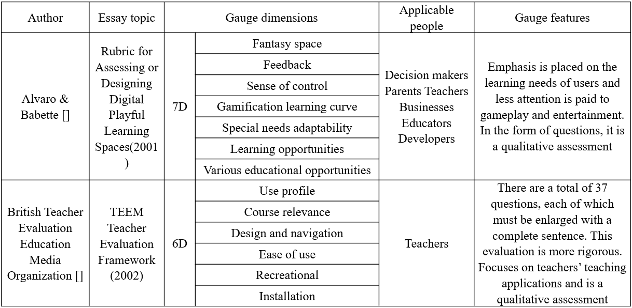

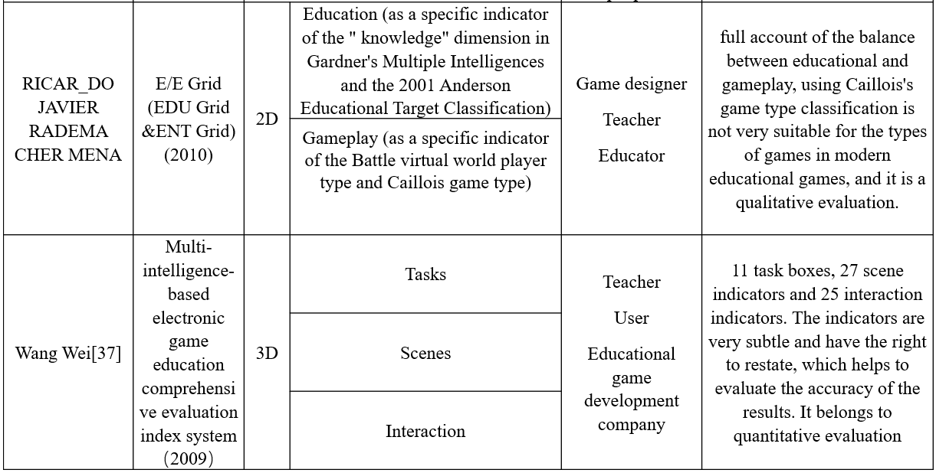

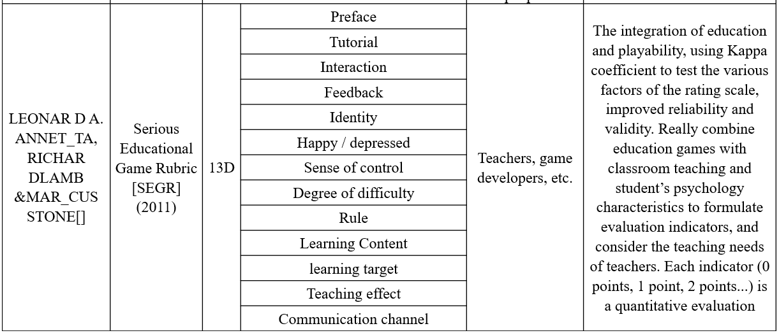

6.2 Evaluate system

The educational experiment method is a universal research method for educational game research. By comparing experiments, it can fully explore the role of educational games in learning effectiveness. The setting of the experimental group and the control group was mainly used to compare the influence of the control variables on the learning effect. Usually, the control group is traditional learning or common online learning methods, while the experimental group can be set as one or more groups. The multiple experimental groups can further explore the effect and impact of specific technology types, or degrees of feedback on the application of virtual reality or augmented reality technology. Pre-test and post-test measures the extent to which the learner's learning effect is improved. It can scientifically prove that the change of the learning result is caused by the use of a certain teaching method or technique and can measure the level of consistency of the subject before learning, if the subject has significant difference level before learning, then can use the high and low score groups to further explore the role of educational games in promoting students of different levels. Postponement testing can measure learner's learning transfer and retention effect. Attitude test and motivation test can collect satisfaction and suggestions of the experimental subjects for educational games and help researchers and educational practitioners improve game design and instructional design. Use an open questionnaire allows the experimenter to express his ideas and experience more flexibly. In addition to using the questionnaire test, it is also possible to collect more information that can be used to analyze the measurement results in conjunction with the classroom observation method and the interview method when the conditions permit. Combined with the characteristics of each evaluation system summarized in the previous section, and the characteristics of virtual reality and augment reality educational games, the following table is the evaluation system for this study. According to the evaluation, the performance, cost, and portability of the device, as well as the user's experience, educational effectiveness, etc. are performed. Among them, the cost performance and portability are inherent attribute characteristics of the device itself. The user experience and the educational effect need to be verified through testing. The experience sense and the educational effect are interviewed through oral questions. Combined with the characteristics of each evaluation system summarized in the previous section, and the characteristics of virtual reality educational games, the following table is based on the evaluation system:

Table 6-3. Educational purposes and target audience for each game in this application

|  |  |  |
| --- | --- | --- |
| Game | Target | Educational goals (effects) |
| AR 3D Coloring Game | 6 year;  Pre-school | Understanding the Earth and the Solar System. Develop children's color recognition and hands-on skills. |
| VR Art Exhibition | 20 year; college | Watching works of art |
| MR Chemistry Lab | 20 year; college | Understand chemical experiment, familiar with the experimental process, observe the experimental phenomenon |

The innovative Wang Wei (2010) researched a multiple-intelligence-based electronic game evaluation scale. Based on the influence of video games on the multiple intelligence of young people, electronic games were divided into language-based and music-based, etc. eight types, and give each type an evaluation gauge and assign weights to it. At present, there are many types of educational games. They all have their own distinct characteristics. It is difficult to align these features with the same gauge to make a correct evaluation. Only the same type of games is comparable. The three models in this study all belong to virtual reality, augmented reality educational games. One of the hallmarks of these games is immersion so that need to experience immersions and senses of control. The main theoretical analysis is qualitative analysis, which confirms the lack of quantitative analysis. Based on the above introduction and the features of virtual reality, augmented reality programs and two types of target populations, this paper has designed the following evaluation gauge, table7-4. Besides, of the three applications in this study, the 3D coloring game is for preschool children, and the Chemistry lab and art exhibition are for high school students. Therefore, the evaluation system is divided into two categories. The first category is the children's group, and the second is the adult group.

Table 6-4: The appraisal system's gauge dimension design in this study

|  |  |  |
| --- | --- | --- |
| Gauge dimensions | Evaluation method | |
| The first category | The second category |
| hardware equipment | record | record |
| Immersive | Interview | Interview |
| Educational effect | Interview | Questionnaire |
| Interaction and Sense of control | Interview | Interview |
| Degree of difficulty | Interview | Questionnaire |

However, just using evaluation scales to judge the application value of educational games is not comprehensive enough, and the evaluator still needs to examine the changes in learning behaviors and learning results after learners use educational games in order to make in-depth, comprehensive and reasonable evaluations.

6.3 Evaluations for the 3 cases

In the previous section, we introduced that we divided the three games into two categories for evaluation. The four applications were targeted at different ages. The AR 3D coloring games targeted preschool children. The average age is 6 years old, including 5 in the experimental group and 5 in the comparison group. The selected children were familiar with the basic operation of the mobile phone, while the VR art Exhibition and the VR Chemistry Lab focused on the subject of extended education and the choice of subjects. There are 10 undergraduates in art and science. There are no gender restrictions. The test tasks are divided into four groups. Each game has an experimental group and a comparison group. The subjects of the experimental group implement the projects developed in this thesis and compare the group's object experience with the traditional group games with the same function as the experimental group. As shown in the table below.

Table 6-5. Number of subjects and grouping

|  |  |  |  |  |  |  |  |  |  |  |  |
| --- | --- | --- | --- | --- | --- | --- | --- | --- | --- | --- | --- |
| Game | AR 3D coloring game | | | VR art Exhibition | | | MR Chemistry Lab | | | | |
| AR | Non- AR | Normal | VR | Non- VR | Normal | MR | Non- MR | Normal |
| Number | 5 | 5 | 5 | 5 | 5 | 5 | 5 | 5 | 5 |
| Total | 15 | | | 15 | | | 15 | | | |

6.3.1 The first category

This evaluation is aimed at the game 3D coloring game. This is a puzzle virtual reality augmented reality game developed for preschool children. The participants of this category include game developers and game target groups (preschoolers). Subjects were divided into experimental group 5 and control group 5 persons. The children in the experimental group used the AR game to recognize the Earth, and the children in the control group obtained the knowledge of the Earth through plane pictures and lectures. The evaluation contents include: 1. Comparing the earth effect of the experimental group and the control group; 2. Examining the emotional attitude of the experimental subjects after using the AR. After using the AR to guide the subjects, children in the experimental group used the AR tool to recognize the shape of the earth. Through the use of coloring to understand the distribution and contours of the continents and the ocean, the children in the control group adopted traditional teaching methods, flat images and Languages are taught to understand the contours of the Earth and continents, and the results of the first type of game evaluation are shown in the following table:

Table 6-6 ：The first category evaluation result

|  |  |  |  |
| --- | --- | --- | --- |
| Gauge dimensions | Evaluation method | Evaluation result | |
| Experimentalgroup | Control group |
| Interesting | Interview | Vivid and interesting | Dull |
| Hardware equipment | Record | Requirements for the game: Android phone, printed identification map  Required hardware is readily available and portable | Flat picture of the earth |
| Educational effect | Interview | The subject has a preliminary understanding of the globe |  |
| Interaction & Sense of control | Interview | Simple operation: click  Can achieve precise control |  |
| Degree of difficulty | Interview | Simple |  |

6.3.2 The second category

This review includes VR Art Exhibition and MR Chemistry Lab. These are two types of virtual reality augmented reality games developed for college students. Participants in this category include game developers (game development practitioners) and game target audiences (college students). The results are as follows:

Table 6-7. The second category VR Art Exhibition evaluation result

|  |  |  |  |
| --- | --- | --- | --- |
| Gauge dimensions | Evaluation method | Evaluation result | |
| Experimentalgroup | Control group |
| Hardware equipment | Record | Oculus HMD, Hand Controllers,  Expensive, poor mobility |  |
| Immersive | Interview | Strong |  |
| Educational effect | Questionnaire |  |  |
| Interaction & Sense of control | Interview | Interaction is not nature but accuracy, feel dizziness when worn for a long time |  |
| Degree of difficulty | Questionnaire | Biased difficult |  |

Table 6-8. The second category MR Chemistry Lab evaluation result

|  |  |  |  |
| --- | --- | --- | --- |
| Gauge dimensions | Evaluation method | Evaluation result | |
| Experimentalgroup | Control group |
| Hardware equipment | Record | Oculus HMD, Hand Controllers,  Expensive, poor mobility |  |
| Immersive | Interview | Immersion is stronger and can be enhanced by the design of the laboratory art is more like a real laboratory |  |
| Educational effect | Questionnaire | Learned and repeatedly practiced the basic process of chemical experiments  Observed experimental phenomena |  |
| Interaction & Sense of control | Interview | Good interaction accuracy, but dizziness when worn for a long time |  |
| Degree of difficulty | Questionnaire | Biased difficult |  |

Ⅶ Conclusions

“The pedagogy of constructive learning and game-based learning tells us that children learn best when they are hands-on experience,” says Corbett. Ability to introduce experimental knowledge without leaving the classroom, which gives the educational experience an unparalleled value. Students are no longer attending lectures but follow annotations in the headset to get a real experience. Inge Knudsen, a virtual reality education expert, has set up a virtual construction site with many safety issues. Students can walk around in a virtual environment and find insecure places to take pictures. Such cases cannot be performed in real life. Therefore, they are particularly suitable for virtual worlds. The immersive virtual scene allows students to learn and experience any area of ​​work and daily life. The defects and limitations in education in reality are solved and improved by using mixed reality technology, which makes the education process vivid and exciting, and some of the scenarios and effects that are not possible under the traditional education model become possible in the virtual world. In addition, virtual reality arises the probability of participation will eventually shift the students' desire to explore from the beginning of play to learning and thinking.

The combination of virtual reality and augmented reality technology and education will increase the efficiency of classroom teaching in the future. Because the traditional teaching model is that the teacher is teaching the whole class in an indoctrinating and indiscrimination way, teaching using Mixed Reality technology will enable the classroom teaching to be organized in a personalized, self-directed, and experiential way. Each student can personally listen to the teacher and give lectures in a virtual environment and interact with the teachers in the virtual environment. In a traditional classroom, one person speaks to the whole class, and virtual reality classrooms are equivalent to having a teacher in front of each student. At the same time, augmented reality technology can also stereo display static text and pictures, increase the interactivity, interest, and sense of reality when reading, create realistic situations, visualize abstract learning content through 3D models, and change the contents of microscopic learning. Visualization and complex learning content become simple and help students understand and remember abstract concepts. Using virtual reality and augmented reality as educational tools in the classroom, students will be presented with a virtual world that can interact and interact. This will not only satisfy students’ sense of experience and curiosity, but also impart knowledge in an innovative manner, which can greatly enhance teachers’ teaching effects, stimulate students' interest in learning, and improve students' learning efficiency.

The three Mixed Reality education application cases described above, from a disciplinary perspective, are designed to teach elementary education in the field of chemical geography for elementary education. Compared to the use of Virtual Reality devices such as the Oculus HMD, the Augmented Reality environment does not require the use of heavy helmets and does not need to be placed the dedicated locator and a specific range of activities for capturing user space locations only require a tablet or a mobile phone (with its own camera) to achieve the integration and interaction of the real environment and virtual objects. Therefore, a learning environment with a low requirement for hardware conditions is more likely to be implement at school.

Compared to other mature technologies in education research, the research of Mixed Reality applied in education is still in the initial stage. The number of samples in quantitative research is small. Qualitative research mainly depends on the availability, preference and efficiency of users’ self-statement. Assessing the learning effect, in addition, the methods used are mainly based on design studies, case studies, and a few experimental studies. However, from the case of the author's independent research and development, it can be seen that most students show a positive attitude toward mixed reality teaching tools or environments.

Appendix I: Virtual & Augmented Education Gameplay

Appendix II: Questionnaire for Subjective Evaluation

Appendix III: Interview Questions and Answers

# **References**

1. AR, http://whatis.techtarget.com/definition/augmented-reality-AR, [Article(CrossRef Link)](http://whatis.techtarget.com/definition/augmented-reality-AR)

——http://www.baike.com/wiki/ugc?hf=youdaocitiao&pf=youdaocitiao

1. <http://vr.99.com/news/07192017/001616650.shtml>
2. 作者：胡痴儿2.0。链接：https://www.zhihu.com/question/36979454/answer/95047656
3. 作者：犬一。链接：https://www.zhihu.com/question/36979454/answer/125991422
4. 作者：世界两侧。链接：<https://www.zhihu.com/question/36979454/answer/90834848>
5. 作者：陈儿.链接：<https://www.zhihu.com/question/36979454/answer/191543111>
6. <https://www.quora.com/What-is-the-difference-between-augmented-reality-and-mediated-reality-1>
7. <http://jp.trane.com/commercial/global/latin-america/es/markets/k-12-education.html>
8. <https://zhuanlan.zhihu.com/p/22135486>
9. The Virtual Lab (Physics & Chemistry) for Malaysia’s Secondary School [accessed Oct 3, 2017].
10. Augmented Reality: What Does It Mean for UX?
11. <http://www.weihk.cn/article/237816>
12. Google Translate review: how well does the new app work?
13. WU H K,LEE S W Y,CHANG H Y,et al.Current Sta-tus,Opportunities and Challenges of Augmented Reality in Education[J].Computers & Education(S0360-1315),2013,62(3)： 41-49.
14. The Economics.The Promise of Augmented Reality[DB/OL]. (2017-02-04)[2017-02-28].http://www.economist.com/news/ science-and-technology/21716013-replacing-real-world-virtual-one-neat-trick-combining-two.
15. NUNEZ M,QUIROS R,NUNEZ I,et al.Collaborative Aug-mented Reality for Inorganic Chemistry Education In 5th WSEAS/IASME International Conference on Engincering Education,Heraklion,Greece,July 22-24,2008.
16. GOLDMAN SACHS.Virtual & Augmented Reality Under-standing the Race for the Next Computing Platform[DB/OL]. (2016-03-09)[2017-02-20].http://www.goldmansachs.com/ our-thinking/pages/virtual-and-augmented-reality-report.html.
17. WATSON J B.Psychology as the Behaviorist Views It[J].Psy-chological Review(S0033-295X),1913,20(2)：158.
18. PIAGET J.The Stages of the Intellectual Development of the Child.Educational Psychology in Context:Readings for Future Teachers [M].1965.
19. JONASSEN D H.Thinking Technology:Toward a Construct-ivist Design Model[J].Educational Technology(S0013-1962), 1994,34(4)：34-37.
20. 蔡苏, 王沛文, 杨阳, 等. 增强现实(AR) 技术的教育应用综述 [J]. 远程教育杂志,2016,(5)：27-40.
21. RYFFEL M,MAGNENAT S.Augmented Creativity: Bridging the Real and Virtual Worlds to Enhance Creative Play[C].Proceedings of the SIGGRAPH Asia 2015 Mobile Graphics and Interactive Applications,Kobe:ACM，2015：1-12.
22. HORNECKER E,DUNSER A.Of Pages and Paddles: Children’s Expectations and Mistaken Interactions with Physical-digital Tools [J].Interacting with Computers (S0953-5438),2009,21(1)：95-107.
23. Virtual &Augmented Reality The Goldman Schs Group,Inc. Jan 13,2016.
24. <https://zhuanlan.zhihu.com/p/32865565>
25. Human interface guidelines <https://developer.apple.com/ios/human-interface-guidelines/technologies/augmented-reality/>
26. Thomas Caudell and David Mizell Augmented reality: An application of heads-up display technology to manual manufacturing processes
27. 王丹，段渭军，李星，SOOLDE在工科院校实验合成中应用初探，现代教育技术Modern Educational Technology， Vol.20, No, 12, 2010
28. <http://www.shafa.com/articles/zIHzY7BRArZmpcYY.html>
29. <https://t.qianzhan.com/kuaixun/detail/161118-3fa346e7.html>
30. iPhone X’s Emoji Innovation Tracks Your Face
31. AR, http://whatis.techtarget.com/definition/augmented-reality-AR, [Article(CrossRef Link)](http://whatis.techtarget.com/definition/augmented-reality-AR)

50. Shelton B, Hedley N. Using Augmented Reality for Teaching Earth - Sun Relationships to Undergraduate Geography Students [C]. The First IEEE International Workshop, Darmstadt, Germany，September 29，2002：1-8.

[53]Schank Roger C.,Kass Alex.A goal-based scenario for high school students[J].Communications of the Acm,1996,39(4):28-29

[54] Byung-Taek Kim, “The glimmering of an idea”, 2014

International Invitation Exhibition of KDAA.

[55] Byung-Taek Kim, “Emit a brillant light”, 2015

International Invitation Exhibition of KDAA.

[56] Byung-Taek Kim, “Poseidon”, 2013 International

Invitation Exhibition of KDAA.